EMAIL SPAM DETECTION USING MACHINE LEARNING

A PROJECT REPORT

Mini Project (01CE0609)
Submitted by

YASH TALAVIYA

92410103105

TIRTH BHUT

924101031093

PRATHAM GAJRA

92410103106

BACHELOR OF TECHNOLOGY
in

Computer Engineering


Faculty of Engineering & Technology

Marwadi University, Rajkot
April, 2026



Mini Project (01CE0609)
Department of Computer Engineering
Faculty of Engineering & Technology
Marwadi University
A.Y. 2025-26
CERTIFICATE
This is to certify that the project report submitted along with the project entitled Email Spam Detection using Machine Learning has been carried out by Yash Talaviya (92410103105), Tirth Bhut (92410103093), Pratham Gajra (92410103106) under my guidance in partial fulfillment for the degree of Bachelor of Technology in Computer Engineering, 6th Semester of Marwadi University, Rajkot during the academic year 2025-26.

Prof. Yogeshwar Prajapati | Prof. (Dr.) Krunal Vaghela
Assistant Professor | Professor & Associate Dean
Department of Computer Engineering | Department of Computer Engineering



Mini Project (01CE0609)
Department of Computer Engineering
Faculty of Engineering & Technology
Marwadi University
A.Y. 2025-26

DECLARATION

We hereby declare that the Mini Project (01CE0609) report submitted along with the Project entitled Email Spam Detection using Machine Learning submitted in partial fulfilment for the degree of Bachelor of Technology in Computer Engineering to Marwadi University, Rajkot, is a bonafide record of original project work carried out by me/us at Marwadi University under the supervision of Prof. Yogeshwar Prajapati and that no part of this report has been directly copied from any students’ reports or taken from any other source, without providing due reference.

Name of the Student Sign of Student
- ______________________ _______________
- ______________________ _______________
- ______________________ _______________

Acknowledgement
We are genuinely grateful to everyone who supported us throughout this project. Without their help, completing this work would not have been possible for us.
First and foremost, we want to thank our internal guide, Prof. Yogeshwar Prajapati, Assistant Professor, Department of Computer Engineering, Marwadi University. He was always available whenever we needed guidance, patiently answered our questions, and gave us the kind of practical suggestions that helped us move forward every time we got stuck. His way of teaching us to think through problems rather than just giving ready answers made a real difference.
We thank Prof. (Dr.) Krunal Vaghela, Professor and Associate Dean, Department of Computer Engineering, for providing the academic environment and infrastructure that made this project possible. The department's support in terms of computing resources and library access throughout the semester was something we genuinely relied on.
We are thankful to all the faculty members of the Department of Computer Engineering who took time at various points to discuss ideas with us, ask us difficult questions during reviews, and push us to improve the quality of our work.
Finally, we would like to thank our family and friends for their support and motivation.

Abstract
Email communication has become an essential part of modern life, supporting both personal and professional interactions. However, with the rapid growth in email usage, the number of spam and phishing attacks has also increased significantly. These malicious emails often contain misleading information, fake offers, or harmful links that can lead to data theft, financial loss, and serious security risks. As a result, there is a strong need for an efficient and automated system to identify and filter such emails. This project presents a machine learning-based system for detecting spam emails using advanced text processing and classification techniques. The system begins with the preprocessing of email content, including cleaning, normalisation, and removal of irrelevant data. It then applies TF-IDF (Term Frequency–Inverse Document Frequency) for feature extraction, which converts textual data into meaningful numerical representations. A Linear Support Vector Classifier (LinearSVC) is used as the primary model due to its effectiveness and fast performance in text classification tasks. Additionally, a calibration technique is applied to generate probability-based outputs, allowing the system to provide confidence scores for each prediction. The model is trained and tested on a large dataset containing both spam and legitimate emails. Its performance is evaluated using standard metrics such as accuracy, precision, recall, and F1-score. Experimental results demonstrate that the proposed system achieves high accuracy while maintaining low false positive and false negative rates. Furthermore, the system is capable of real-time classification, making it practical for deployment in real-world environments. Overall, the proposed approach offers a reliable, efficient, and scalable solution for email spam detection. It can be integrated into email platforms, cybersecurity systems, and web applications to enhance protection against spam and phishing attacks while improving user experience.

List of Figures
Fig 1.1 Gantt Chart 8
Fig 5.1 Flow Chart 27
Fig 7.1 Dataset One Results 33
Fig 7.2 Dataset Two Results 34

List of Tables

Table 1.1 Roles and Responsibilities of Team Members 7
Table 2.1 Literature Review Table 12
Table 7.1 Model Performance Comparison Table 32
Table 7.2 Testing Table 33

Abbreviations

TF-IDF | A Term Frequency – Inverse Document Frequency
SVM | Support Vector Machine
ML | Machine Learning
NLP | Natural Language Processing
RF | Random Forest
NB | Naive Bayes
API | Application Programming Interface
CSV | Comma-Separated Values
EDA | Exploratory Data Analysis
UTF-8 | Unicode Transformation Format – 8 bit
OCR | Optical Character Recognition
BERT | Bidirectional Encoder Representations from Transformers
CNN | Convolutional Neural Network
LSTM | Long Short-Term Memory

Table of Contents

Acknowledgments i
Abstract ii
List of Figures iii
List of Tables iv
List of Abbreviations v
Table of Contents vi
CHAPTER 1: INTRODUCTION 1
1.1 Overview of Email Communication 1
1.2 Definition of Spam Emails 1
1.3 Types of Spam Emails 2
1.4 Challenges in Spam Detection 4
1.5 Need for Machine Learning 5
1.6 Problem Statement 5
1.7 Objectives of the Study 6
1.8 Scope of the Project 7
1.9 Project Planning and Scheduling 7
CHAPTER 2: LITERATURE REVIEW 9
2.1 Overview of Previous Research 9
2.2 Review of Machine Learning Techniques 11
2.3 Analysis of Existing Systems 12
2.4 Limitations of Existing Approaches 18
CHAPTER 3: DATASET DESCRIPTION 20
3.1 Overview of Dataset 20
3.2 Data Collection Methods 20
3.3 Data Attributes and Features 21
3.4 Dataset Used 21
CHAPTER 4: METHODOLOGY 23
4.1 System Overview 23
4.2 Data Preprocessing 23
4.3 Feature Extraction 24
4.4 Machine Learning Algorithms 25
4.5 Model Training and Testing 26
CHAPTER 5: SYSTEM ARCHITECTURE 27
5.1 System Flowchart Diagram 27
5.2 Workflow Explanation 28
CHAPTER 6: IMPLEMENTATION 29
6.1 Tools and Technologies Used 29
6.2 Implementation Steps 30
CHAPTER 7: RESULTS AND ANALYSIS 31
7.1 Performance Metrics 31
7.2 Comparison of Models 32
7.3 Outcome 32
CHAPTER 8: CONCLUSION 35
8.1 Overall Analysis 35
8.2 Advantages 35
8.3 Limitations 35
8.4 Future Enhancements 36
8.5 Project Conclusion and Discussion 36
References 37

CHAPTER 1
INTRODUCTION

1. Introduction
1.1 Overview of Email Communication
Email communication is one of the most widely used digital communication methods in today’s interconnected world. It allows individuals and organisations to exchange messages instantly across geographical boundaries, making it a fast, reliable, and cost-effective means of communication. Emails are extensively used for personal interactions, business correspondence, official notifications, marketing campaigns, and customer support services. Their ability to support attachments such as documents, images, and multimedia further enhances their utility in both professional and personal contexts.
With the rapid expansion of the internet and digital technologies, the number of email users has grown exponentially. Organisations depend heavily on email systems for daily operations, including internal communication, client interactions, and information sharing. As a result, email has become a critical infrastructure component in modern communication systems.
However, this widespread adoption has also made email a prime target for various cyber threats. Malicious activities such as spam, phishing attacks, and malware distribution exploit email systems to deceive users and compromise sensitive information. These threats not only reduce productivity but also pose serious risks to data security and privacy. Therefore, ensuring secure and efficient email communication has become a significant challenge, highlighting the need for advanced detection and filtering techniques.
1.2 Definition of Spam Emails
Spam emails refer to unwanted, unsolicited, and irrelevant messages that are sent in bulk to a large number of recipients, often without their consent. These emails are typically generated automatically and distributed through mass mailing systems, targeting individuals or organisations for advertising, promotion, or malicious purposes. The primary objective of spam is either to promote products and services or to deceive users into performing actions that benefit the sender.
Spam emails often contain misleading subject lines, fake promotional offers, and suspicious links designed to attract user attention. In many cases, they are used as a medium for cyberattacks such as phishing, where attackers attempt to trick users into revealing sensitive information like login credentials, bank account details, or personal identification data. Some spam emails may also include malicious attachments that can install malware, ransomware, or spyware on the user’s system.
There are different types of spam emails, including commercial spam (advertisements), phishing emails, scam emails (lottery or prize fraud), and malware-based spam. Due to their massive volume, spam emails consume significant network bandwidth and storage resources, leading to increased operational costs for organisations. Additionally, they reduce user productivity by cluttering inboxes and making it difficult to identify legitimate emails.
Overall, spam emails pose serious threats to cybersecurity, privacy, and system efficiency, making their detection and filtering a crucial area of research in modern communication systems.

1.3 Types of Spam Emails
Spam emails can be categorised by purpose, content, and level of threat. The major types are as follows:
- Commercial Spam (Advertising Emails): Commercial spam emails are primarily used for promoting products, services, or websites to a large number of users without their consent. These emails often contain attractive offers, discounts, or marketing campaigns designed to grab attention. While they are not always harmful, they can overwhelm inboxes and reduce productivity. Users may find it difficult to distinguish between legitimate promotional emails and spam, leading to inefficiency and frustration in managing email communication.
- Phishing Emails: Phishing emails are malicious messages designed to deceive users into sharing sensitive information such as passwords, credit card details, or personal data. These emails often appear to be from trusted sources like banks, social media platforms, or official organisations. They use urgent language or fake warnings to create panic and prompt quick action. Phishing attacks are highly dangerous as they can lead to identity theft, financial loss, and unauthorised access to user accounts.
- Scam or Fraud Emails: Scam emails aim to manipulate users by presenting false opportunities such as lottery winnings, inheritance claims, or urgent financial assistance requests. These emails often create a sense of urgency or emotional appeal to trick users into sending money or sharing confidential information. Victims of such scams may suffer significant financial losses. These emails are usually poorly written but can still deceive users who are unaware of such tactics.
- Malware-Based Spam: Malware-based spam emails contain harmful attachments or links that install malicious software on the user’s system when opened. This software may include viruses, ransomware, spyware, or trojans that can damage the system, steal data, or monitor user activity. These emails often disguise malicious files as important documents or invoices. Once executed, they can compromise system security and lead to serious consequences such as data breaches or system failure.
- Spoofed Emails: Spoofed emails involve the falsification of the sender’s address to make the message appear as if it is coming from a legitimate or trusted source. Attackers use this technique to gain user trust and increase the chances of successful phishing or fraud. These emails may look identical to genuine emails from banks or organisations. Users who fail to verify the sender’s authenticity may unknowingly provide sensitive information or perform harmful actions.
- Chain Emails: Chain emails are messages that encourage recipients to forward them to multiple people. They often contain exaggerated claims, emotional content, or warnings about bad luck if not forwarded. While they may not always be harmful, they contribute to unnecessary email traffic and can spread misinformation. In some cases, they may also include hidden malicious links or scams, making them a potential security concern.
- Empty or Blank Spam Emails: Empty or blank spam emails contain little or no visible content. These emails are often used by spammers to test whether an email address is active or to bypass spam filters. Once a user interacts with such emails, their address may be marked as valid, leading to more spam in the future. Although they may seem harmless, they play a role in the larger spam ecosystem and should be handled cautiously.
1.4 Challenges in Spam Detection
Spam detection is a critical task in email security, but it faces several challenges due to the evolving nature of cyber threats and the diversity of email content. These challenges make it difficult to accurately distinguish between legitimate emails and spam.
- Evolving Nature of Spam Techniques: Spammers continuously modify their strategies to bypass detection systems. They use techniques such as obfuscation, random text insertion, and image-based spam to avoid being identified by traditional filters. As a result, spam detection models must be regularly updated to handle new patterns and attack methods.
- High False Positives and False Negatives: One of the major challenges is maintaining accuracy. A false positive occurs when a legitimate email is marked as spam, while a false negative occurs when spam is not detected. Both cases are problematic, as they either block important communication or allow harmful content to reach users.
- Large Volume of Email Data: Email systems handle a massive volume of messages daily. Processing and analysing such large datasets in real time requires efficient algorithms and significant computational resources. This makes scalability a key concern in spam detection systems.
- Variety of Spam Content: Spam emails come in multiple formats, including text, images, attachments, and links. Some spam messages use minimal text or rely on embedded images to convey information, making it harder for text-based filtering systems to detect them effectively.
- Language and Cultural Variations: Spam emails are sent in different languages and styles, targeting users from various regions. Detection systems must be capable of understanding multilingual content and cultural nuances to accurately identify spam.
- Adversarial Attacks: Spammers may deliberately craft emails to confuse machine learning models by slightly modifying known spam patterns. These adversarial techniques can reduce the effectiveness of trained models and require more robust and adaptive detection mechanisms.
- Data Imbalance Problem: In most datasets, legitimate emails (ham) significantly outnumber spam emails or vice versa. This imbalance can affect the performance of machine learning models, causing them to be biased toward one class.

1.5 Need for Machine Learning in Spam Detection
The rapid growth of email communication has led to a significant increase in spam emails, making traditional rule-based filtering techniques less effective. Earlier spam detection systems relied on predefined rules, keyword matching, and blacklist-based approaches. However, these methods struggle to adapt to new and evolving spam patterns, as spammers continuously modify their strategies to bypass such filters. This limitation creates the need for more intelligent and adaptive solutions.

Machine learning plays a crucial role in addressing these challenges by enabling systems to automatically learn patterns from data. Instead of relying on fixed rules, machine learning models analyse large datasets of emails and identify distinguishing features between spam and legitimate (ham) messages. These features may include word frequency, email structure, sender behaviour, and embedded links. As a result, machine learning models can generalise better and detect previously unseen spam.

Another important advantage of machine learning is its ability to improve over time. With continuous training on new data, models can adapt to emerging spam techniques such as phishing, spoofing, and malware-based attacks. This makes them more robust and effective compared to static filtering methods.

Machine learning also helps in reducing false positives and false negatives by optimising classification accuracy. Advanced algorithms such as Naïve Bayes, Support Vector Machines, Random Forest, and deep learning models provide high performance in spam detection tasks. Additionally, these models can handle large volumes of email data efficiently, making them suitable for real-time applications.
1.6 Problem Statement
- Email has become a primary mode of communication, but the increasing volume of spam emails poses serious challenges to users and organisations.
- Spam emails include unwanted advertisements, phishing attempts, fraud messages, and malware distribution, which threaten data security and user privacy.
- Traditional spam detection techniques such as rule-based filtering and keyword matching are no longer effective against modern and evolving spam techniques.
- Spammers use advanced methods like obfuscation, spoofing, and multimedia content to bypass existing filtering systems.
- High false positives (legitimate emails marked as spam) and false negatives (spam emails not detected) reduce the reliability of current systems.
- The large volume and diversity of email data make real-time processing and accurate classification difficult.
- Multilingual content, varying formats, and imbalanced datasets further complicate spam detection.
- There is a need for an intelligent, adaptive, and automated system that can accurately classify emails.
- Machine learning-based approaches are required to improve detection accuracy, reduce errors, and handle evolving spam patterns.
1.7 Objectives of the Study
- Advanced Text Analytics: To design and implement a modular text preprocessing pipeline involving tokenisation, stop-word removal, lemmatisation, and TF-IDF (Term Frequency-Inverse Document Frequency) vectorisation to convert raw text into machine-readable numerical data.
- Algorithmic Benchmarking: To train, tune, and evaluate a variety of classification algorithms, including Naive Bayes, Support Vector Machines (SVM), and Random Forest, to determine which architecture offers the best balance of precision and recall.
- Cross-Domain Validation: To validate the model's robustness and generalizability by testing it across multiple distinct datasets, such as the Kaggle, ensuring the filter is not "overfit" to a single source of data.

1.8 Scope of the Project
In-Scope (Capabilities)
- Text Analysis: Processing email/SMS body text to extract semantic features.
- Binary Classification: Predicting labels (Spam vs. Ham) with high accuracy.
- Evaluation: Generating confusion matrices and performance metrics (Precision, Recall, F1).

Out-of-Scope (Limitations)
- Non-Text Media: Analysing file attachments (PDFs/ZIPs) or text within images (OCR).
- Real-Time Filtering: The system currently operates as an offline analytical tool rather than a live network gateway.
- Header Analysis: Focus is strictly on message content, excluding low-level metadata or IP reputation.

  - Project Planning and Scheduling
    - Roles and Responsibilities
Table 1.1 Roles and Responsibilities of Team Members
Team Member | Enrollment No. | Specific Responsibilities
Yash Talaviya | 92410103105 | Dataset collection, TF-IDF implementation, meta-feature design, model training, confidence score testing, live email testing, Literature review (25 papers)
Tirth Bhut | 92410103093 | Data cleaning and preprocessing pipeline, confusion matrix analysis, classification report generation, and performance comparison table
Pratham Gajra | 92410103106 | PPT preparation, project report writing, flowchart design, and presentation delivery

    - Scheduling
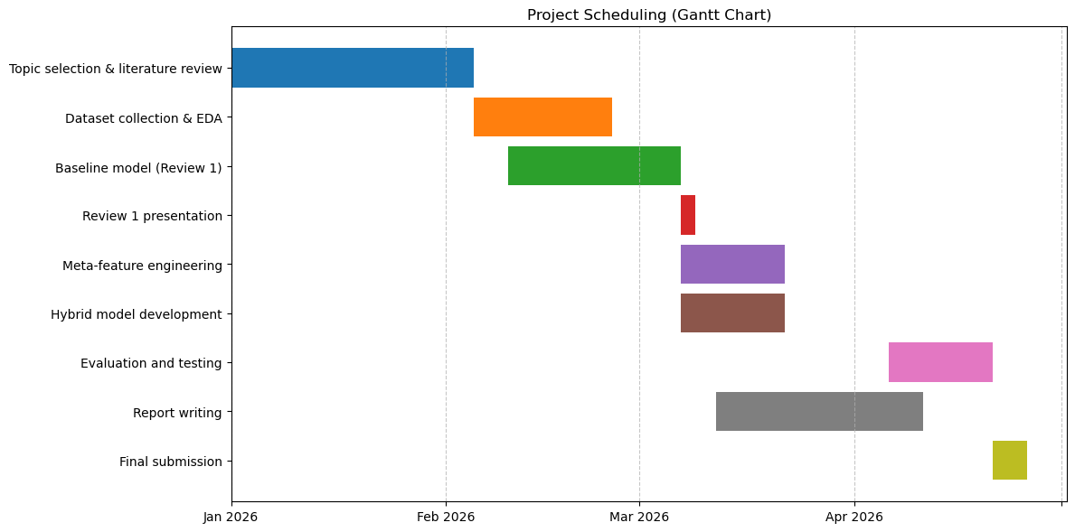
Fig 1.1 Gantt Chart

CHAPTER 2
LITERATURE REVIEW

2. Literature Review
2.1 Overview of Previous Research
In this study, Kamal Taha has introduced SMART, an advanced and adaptive spam detection framework that integrates multi-objective adversarial training, semantic enrichment using BERT, and reinforcement learning for dynamic spam detection. By utilising sophisticated techniques such as text tokenisation, word embeddings, and K-means clustering, SMART effectively enhances the detection of spam emails, even as adversarial tactics evolve. The framework was evaluated against several existing methods, showing consistent improvements in performance across multiple benchmarks. Our results demonstrate SMART’s robustness in handling diverse email structures and its superior generalisation capabilities in comparison to methods like FT+HAN, MOBGOA, and OPTICS. These findings suggest that SMART is well-suited for real-world applications, ensuring more secure and reliable email communication [1].

Takashi Koide et al. introduce ChatSpamDetector, a system that uses large language models (LLMs) to detect phishing emails. By converting email data into a prompt suitable for LLM analysis, the system provides a highly accurate determination of whether an email is phishing or not. Importantly, it offers detailed reasoning for its phishing determinations, assisting users in making informed decisions about how to handle suspicious emails. We conducted an evaluation using a comprehensive phishing email dataset and compared our system to several LLMs and baseline systems. We confirmed that our system using GPT-4 has superior detection capabilities with an accuracy of 99.70%. Advanced contextual interpretation by LLMs enables the identification of various phishing tactics and impersonations, making them a potentially powerful tool in the fight against email-based phishing threats [3].

Dhara Abhinav et al. have proposed a hybrid email spam detection system that leverages natural language processing and machine learning to accurately identify and block unwanted emails. The system utilises text vectorisation techniques, specifically CountVectorizer, in combination with a Multinomial Naive Bayes classifier for effective spam classification. Advanced preprocessing steps such as stopword removal, stemming, and normalisation enhance model input quality. The proposed approach is lightweight, scalable, and demonstrates strong performance in terms of precision, recall, and overall accuracy. Comparative analysis with other models confirms the efficiency of our method for real-time deployment in email servers or web applications. This system is designed to
improve continuously with evolving spam patterns and ensure users' inboxes remain clean and secure [4].

Khalid Iqbal et al. have used the spambase UCI dataset of 4601 emails. The experiment was performed using different machine learning classifiers, which are NB, RF, KNN, RBF, DT, ANN, LR and SVM. We evaluate the performance of all the classifiers and get the highest accuracy of 98.06% using the Multilayer Perceptron classifier. We use the feature selection technique, which is Point-Biserial selection on each classifier to select the best features from the rest of all. The classifiers Naive Bayes, Random Forest, K-Nearest Neighbour, Radial Basis Function, Decision Tree, Artificial Neural Network, Logistic Regression and Support Vector Classifier achieved accuracy of 94.47, 95.00, 90.87, 94.02, 95.02, 98.06, 97.71 and 98%, respectively. The best performance is achieved by ANN (Multilayer Perceptron) which obtained an accuracy of 98.06%. We select the best features in our model using Point-Biserial feature selection and apply traditional machine learning algorithms [5].

Nowadays, emails are used across almost every field, spanning from business to education. Broadly, emails can be categorised as either ham or spam. Email spam, also known as junk emails or unwanted emails, can harm users by wasting time and computing resources, along with stealing valuable information. The volume of spam emails is rising rapidly day by day. Detecting and filtering spam presents significant and complex challenges for email systems. Traditional identification techniques like blocklists, real-time blackhole listing, and content-based methods have limitations. These limitations have led to the advancement of more sophisticated machine learning (ML) and deep learning (DL) methods for enhanced spam detection accuracy. In recent years, considerable attention has focused on the potential of ML and DL methods to improve email spam detection. A comprehensive literature review is therefore imperative for developing an updated, evidence-based understanding of contemporary research on employing these methods against this persistent problem. Ekramul Haque Tusher et al. aim to systematically identify various ML and DL methods applied for spam detection, evaluate their effectiveness, and highlight promising future research directions considering gaps. By combining and analysing findings across studies, it will obtain the strengths and weaknesses of existing methods. This review seeks to advance knowledge on reliable and efficient integration of state-of-the-art ML and DL into identifying email spam [6].

Aditi Patil et al. have explored various supervised learning approaches for spam detection, including Naive Bayes, Support Vector Machines, Random Forests, and Neural Networks. It discusses the importance of feature selection, the impact of data imbalance, and the challenges of real-world deployment. We also introduce a hybrid detection framework that combines heuristic pre-filtering with machine learning-based classification and feedback-based model updates. Through this comprehensive study, we highlight how machine learning enables intelligent, scalable, and highly accurate spam filtering systems suitable for modern communication environments [7].
2.2 Review of Machine Learning Techniques
Different machine learning techniques have been applied:
- Naive Bayes: Probabilistic model, simple and fast
- Support Vector Machine (SVM): High accuracy for text classification
- Random Forest: Ensemble model, handles complex patterns
- Logistic Regression: Effective for binary classification
- Deep Learning Models: BERT, CNN, LSTM for advanced detection
Each technique has its advantages and limitations.
In comparing approaches, deep neural networks often provide high accuracy but demand heavy computational power. Conversely, our review indicated that for TF-IDF vectorised text data, traditional supervised learning models like SVMs provide excellent accuracy and generalisation with significantly less computational overhead and training time.
2.3 Analysis of Existing Systems
Table 2.1 Literature Review Table
Ref. | Methodology | Key Findings | Accuracy | Dataset | Limitations | How to Overcome Limitations
[1] | SMART Framework: Combines Word2Vec, K-means clustering, BERT for semantic enhancement, Multi-objective adversarial training, and Reinforcement Learning (RL). | Traditional static rules struggle with evolving spam. RL and adversarial training allow the model to adapt dynamically to new spammer tactics. | Accuracy: >92%. | References standard datasets like Enron in related work, though a specific experimental dataset is not explicitly detailed in the snippet. | Traditional methods fail against sophisticated adversarial attacks and lack adaptability. | Proposed Solution: Use reinforcement learning to update detection policies dynamically and adversarial training to robust against attacks.
[2] | OOAD Methodology: Supervised ML algorithms (Naive Bayes, SVM, Random Forest) with NLP techniques like TF-IDF. | SVM and Random Forest are highly effective. OOAD provides a modular, scalable design. | Accuracy: >94%. | Labelled dataset of 5,572 messages (4,825 Ham, 747 Spam) (Matches SMS Spam Collection stats). | Rule-based approaches are easily evaded. System scalability and maintainability are often overlooked. | Proposed Solution: Integrate Object-Oriented Analysis and Design (OOAD) for modularity and use robust ML models for better accuracy.
[3] | LLM-based: Uses GPT-4 with prompt engineering (Chain-of-thought). Includes email parsing, decoding, and simplification to fit token limits. | LLMs provide detailed reasoning for classifications, increasing user trust. GPT-4 outperforms Llama 2 and PaLM 2. | Accuracy: 93.70% (GPT-4). | Custom Dataset: Collected recent phishing and legitimate emails (as public datasets like Enron are outdated). | LLM token limits restrict input size. Public datasets are outdated. Black-box models lack explainability. | Proposed Solution: HTML/text simplification to manage tokens. Generate detailed rationales for users.
[4] | Hybrid ML: Count Vectorizer (Bag-of-Words) with Multinomial Naive Bayes. Preprocessing includes stopword removal and stemming. | Lightweight models like Naive Bayes are scalable and effective for real-time deployment. | Strong performance in precision, and accuracy (exact % not in snippet). | SMS Spam Collection Dataset (UCI): 5,572 messages (4,825 Ham, 747 Spam). | High false positives in traditional filters. Computational efficiency vs. accuracy trade-off. | Proposed Solution: Use lightweight vectorisation (Count Vectorizer) and Naive Bayes for a balance of speed and accuracy.
[5] | Point-Biserial Correlation for feature selection. Algorithms: SVM, ANN, KNN, RF, DT, Logistic Regression. | Feature selection is critical. SVM and ANN outperformed other classifiers. | SVM Accuracy: 91.00%; ANN Accuracy: 92.06%. | UCI Spambase Dataset (approx. 5,000 instances). | Overfitting in complex models (like ANN) with small datasets. Previous studies often lacked rigorous feature selection. | Proposed Solution: Apply Point-Biserial feature selection to reduce dimensionality and use 10-fold cross-validation.
[6] | Review Study: Analyses ML, Deep Learning (CNN, LSTM, BERT), and Fuzzy Systems. | DL methods are superior but resource-intensive. Hybrid models (e.g., Fuzzy-SVM) show promise. | Cites SVM at ~91% and DL models >92%. | Reviews various datasets, including CSDMC2010, Enron, and SpamAssassin. | Data imbalance, concept drift (evolving spam), and lack of interpretability in Deep Learning models. | Proposed Solution: Adversarial training, Explainable AI (XAI), and Hybrid systems.
[7] | Supervised Learning: Review of Naive Bayes, SVM, RF, NN. Proposed Hybrid Framework (Heuristic + ML). | ML adapts to patterns that static rules miss. Feature engineering is key. | SVM Accuracy: 92.10%; | Mentions SpamAssassin, Enron, Ling-Spam. | Adversarial spam (obfuscation), Data Imbalance, Real-world deployment challenges. | Proposed Solution: Continuous retraining, SMOTE for imbalance, and a hybrid framework with feedback loops.
[8] | Comparative Analysis: SVM, Decision Tree, Naive Bayes using TF-IDF and Bag-of-Words. | SVM is the most effective for complex datasets. Naive Bayes and DT are satisfactory but less robust. | SVM Accuracy: 91.48%. | Kaggle Dataset (matches SMS Spam Collection): 5,572 messages (4,825 Ham, 747 Spam). | Overfitting, scalability issues, and maintenance of models. | Proposed Solution: Combine advanced feature extraction with customised SVM kernels.
[9] | Web Integration: RF, KNN, ANN optimised with GridSearchCV. Integrated into a Django Web App. | Random Forest (RF) achieved the highest accuracy. Real-time integration is feasible. | RF Accuracy: 92.78%; KNN: 93.67%; ANN: 92.11%. | Datasets from Ariyadasa et al. (2021) and UNB (2016). | Previous studies lacked end-user integration. KNN is computationally intensive during testing. | Proposed Solution: Deploy the optimal model (RF) via a user-friendly Django web interface for real-time detection.
[10] | Evaluated five ML classifiers (NB, LR, SVM, DT, RF) with feature standardisation. Used SHAP for model interpretability. | Random Forest was the best-performing model. SHAP analysis confirmed classification relies on meaningful attributes rather than random correlations. | Random Forest: 94.57%, SVM: 93.38%, LR: 92.41%. | UCI Spambase dataset (4,601 email instances). | Traditional ML struggles with dynamic modern spam. The study is limited to a single dataset. | Explore hybrid models or deep learning approaches on more diverse, continuously evolving datasets.
[11] | Evaluated NB, LR, Extra Tree, SGD, XGBoost, SVM, RF, and MLP with Count-Vectorizer and TFIDF. Used Grid, Random, and Genetic algorithms (TPOT) for hyperparameter tuning. | Stochastic Gradient Descent (SGD) consistently outperformed other algorithms. Hyperparameter tuning and feature selection were significantly enhanced. | SGD: 96.83% (Ling-Spam), 95.12% (UCI), 94.08% (Custom). Extra Trees average: 95.93%. | Ling Spam, UCI SMS Spam, and a new Custom Dataset featuring a 25% spam rate. | The method relies purely on text-based attributes and may miss advanced evasion techniques like steganography. | Employ image processing specifically to tackle stenographic emails and leverage deep neural network architectures for complex features.
[12] | Topic-based multi-classification (11 categories) using agglomerative hierarchical clustering. Assessed TF-IDF, BOW, Word2Vec, BERT with SVM, NB, RF, and LR. Used OCR to catch "hidden text". | TF-IDF + LR was fastest and best for English; TF-IDF + NB was best for Spanish. The model successfully thwarted "salting" (hidden text) and image-spam via OCR techniques. | English: 94.6% Accuracy, 0.953 F1 (TF-IDF+LR). | Two novel datasets: SPEMC-15K-E (English) & SPEMC-15K-S (Spanish) with ~15K emails each from INCIBE. | Datasets are highly imbalanced. Word embeddings performed poorly due to small domain-specific vocabularies. | Train Word2Vec and BERT models on much larger, domain-specific corpora to better capture vocabulary contexts.
[13] | Systematic review of 15 papers evaluating ML techniques (supervised, unsupervised, and deep learning). Proposes a framework using ensemble models trained on datasets balanced by SMOTE and feature selection. | Naive Bayes, Random Forest (RF), and K-Nearest Neighbour (KNN) are the most frequently mentioned algorithms. RF and KNN showed exceptionally high accuracy rates, often over 99%. | Notes reviewed techniques range from 58% to almost 98% accuracy. | N/A (Review of papers from Google Scholar, IEEE Xplore, etc.). | Existing filters struggle with the sheer volume of multimedia. Models are also heavily impacted by class imbalance. | Utilise ensemble learning alongside data balancing techniques like SMOTE. Develop next-generation models specifically capable of handling large volumes of multimedia data.
[14] | Built an ensemble Stacking model utilising NB, SVM, Decision Tree, and KNN as base learners, with Logistic Regression as the meta-classifier. U | The stacking ensemble effectively aggregated weak algorithms, mitigating individual weaknesses) to significantly reduce false positive and negative rates. | Ensemble Model achieved 95.8% Accuracy and 95.5% F1-score. | Spambase dataset (George Forman, 1999) with 4601 instances and 58 variables. | The dataset relies on older spam structures from 1999, which may not reflect fast-evolving modern spam. Some base models. | Use modern, continuously updated datasets and implement online learning algorithms to continuously refine ensemble performance.
[15] | Integrated Latent Dirichlet Allocation (LDA) for topic modelling with Machine Learning classifiers (Logistic Regression, Naive Bayes, SVM). | Logistic Regression outperformed other models, handling complex relationships well. | Logistic Regression: 95.56% (F-score 0.986). SVM: 96.11%. NB: 95.15%. | Public Kaggle dataset containing 73,932 English messages (balanced ham/spam). | The dataset only consists of English emails. It also did not explore computational intensity or training costs. | Expand the dataset with multiple languages and varying scenarios. Compare computational intensity scales.
[16] | Utilised Tokenisation, Bag of Words, and TF-IDF preprocessing. Applied Naïve Bayes, SVM, KNN, Decision Tree, Random Forest, Bagging, and AdaBoost classifiers. | Multinomial Naïve Bayes gave the best outcome for spam detection, while ensemble methods proved useful by using multiple classifiers for class prediction. | RF 0.92, SVM 0.95. | "spam.csv" from Kaggle (5573 lines) and custom text datasets. | The machine misclassifies some tuples due to class-conditional probabilities in Naïve Bayes. | Filter spam based on trusted and verified domain names. Incorporate a larger corpus beyond the basic text body.
[17] | Systematic literature review analysing ML and deep learning models (SVM, NB, NN, RCNN) for phishing and spam email detection. | Recurrent Convolutional Neural Networks (RCNN) provided the highest accuracy in reviewed works. Supervised ML is the current foundation for spam filters. | Highlights RCNN achieving up to 96.85% in the cited literature. | N/A (Review of multiple datasets). | Current filters lack dynamic feature spaces and struggle with rapidly evolving phishing scams. Most operate purely in monolingual environments. | Implement dynamic feature space updating, multilingual spam recognition, and collaborative manual annotation to create highly dimensional datasets.
[18] | Comprehensive survey categorising supervised, unsupervised, and deep learning techniques (CNN, BERT) applied to spam email filtration. | Supervised methods (SVM, NB) are foundational but require labelled data. Deep learning approaches significantly increase detection rates and capture complex patterns. | Notes: Deep Learning increases accuracy to 97.52%. | N/A (Survey). Discusses Enron, Ling-Spam, and SMS datasets. | Training supervised models on large labelled datasets is time-consuming. Models struggle with evasion techniques like image-based spam. | Investigate unsupervised and reinforcement learning. Utilise advanced deep learning architectures (like BERT) to understand message context better.
[19] | Tested ten supervised ML algorithms (SVM, KNN, NB, NN, RNN, LR, etc.) and integrated a geolocation module to map spammer IP addresses. | High accuracy achieved. The algorithm successfully outputs IP addresses and geolocation maps, directly aiding in the updating of organisational blacklists. | NN: 95.51% (SpamAssassin). SVM: 96.38% (Enron1). LR: 96.22% (Enron1). | SpamAssassin (2551 ham/501 spam), Enron1 (3228 ham/3219 spam), and Kaggle CSV. | Currently evaluates English language emails exclusively and does not natively detect image-based spam tricks. | Expand the language scope. Incorporate image analysis (histograms, file properties) to detect embedded malicious content.
[20] | Implemented the Opinion Rank algorithm and Latent Dirichlet Allocation (LDA). Compared 11 algorithms, including K-Neighbours (KN), Naive Bayes (NB), Random Forest (RF), and Extra Trees. | KN and NB algorithms emerged with the most impressive Accuracy and Precision scores. The system also aids digital forensics by examining browser cookies and caches. | Extra Trees: 97.77%, RF: 97.00%, NB: 95.93% | Raw data from Kaggle (4516 spam, 5169 ham). | Models assume a monolingual environment and struggle to distinguish between new and old tags (handling trust dynamics over time). | Integrate multi-domain trust models and include multiple languages to combat linguistic spam. Study trust dynamics over time.
[21] | Naive Bayes (NB) and Logistic Regression (LR) algorithms combined with text processing (tokenisation, stop word removal). | NB and LR show a trivial difference in performance, though NB performs slightly better on testing data according to their findings. | LR Testing: 94.5%. NB Testing: 94.1%. | Ling spam dataset (1000 emails). | Model behaviour is sometimes unpredictable, and the research is limited to evaluating a few algorithms. | Compare more algorithms and integrate AI/Data Mining to build stronger filter models.
[22] | Literature review of ML methods (NB, SVM, RF, DT, MLP) optimized with bio-inspired methods like Particle Swarm Optimization Algorithm. | Multinomial Naïve Bayes, combined with Genetic Algorithm, performed the best overall among the reviewed models. | Mentions an immune-inspired model identifying >97% in prior studies. | Reviews seven different email datasets. | Rule-based spam detection requires constant updating, and spammers easily evade filters using random sender addresses. | Utilise evolutionary mechanisms to check email content and implement URL verification, models.
[23] | Developed an ensemble model combining Decision Tree (DT), Support Vector Machine (SVM), and Multilayer Perceptron (MLP) | The ensemble model successfully combined the strengths of the base models, producing more consistent results. | Ensemble Model: 96.86%. Individual models: SVM 96.35%, MLP 96.15%, DT 96.74%. | The Enron dataset contains 3672 ham and 1500 spam emails. | The performance of filtering techniques often depends more heavily on the specific data used rather than the algorithm itself. | Combine the knowledge of multiple models into an ensemble framework to achieve optimal and consistent predictive performance.
[24] | Applied Naive Bayes and Support Vector Machine (SVM) binary classifiers with preprocessing steps, including Tokenisation, Stop Word Removal | Naive Bayes effectively calculates class probabilities based on word frequencies, while SVM effectively finds a hyperplane to differentiate the two classes. | Not explicitly specified (built as a GUI application outputting "Spam" or "Not Spam"). | Kaggle dataset. | Searching for the best algorithm and model configurations manually can be extremely time-consuming. | Use self-learning algorithms that can adapt to new data automatically without being explicitly programmed for future spam techniques.
[25] | Implemented a Logistic Regression classification model for binary prediction (spam/ham) using Pandas for data understanding. | The logistic regression model effectively predicts the output of categorical variables, and the system can also be paired with tools to find the IP address of an email. | 96.70% on training data, 96.59% on test data. | Kaggle dataset containing 5572 emails (ham and spam). | Existing approaches are often incapable of proper and efficient detection as spammers constantly compose new messages concerning user interests. | Utilise machine learning models like Logistic Regression that adapt immediately and detect new risks automatically.

2.4 Limitations of Existing Approaches
While various methods have been deployed to combat unwanted emails, existing legacy systems and early machine learning models present several critical limitations that hinder their real-world effectiveness.
- Lack of Adaptability: Traditional rule-based filters rely heavily on static blacklisting and specific keyword triggers. The primary flaw of this architecture is its inability to adapt automatically. When a new threat emerges, network administrators are forced to manually update the filtering rules, which is highly inefficient and creates a wide window of vulnerability.
- High Computational Cost: Recent shifts toward complex deep learning architectures (such as deep neural networks) have improved detection rates, but they demand massive computational power and memory. This high resource overhead makes them expensive and impractical to deploy on standard, lightweight email servers or local hardware.
- Overfitting Issues: Many existing machine learning models fail to generalise well. They suffer from overfitting, meaning they effectively "memorise" the specific dataset they were trained on rather than learning the underlying semantic patterns. As a result, when these models are exposed to cross-domain validation or entirely new data sources, their accuracy drops significantly.
- Limited and Imbalanced Datasets: Historical research models are frequently trained on outdated or highly imbalanced datasets. In many collections, legitimate "ham" emails heavily outnumber "spam" messages. Training a model on this skewed data often creates a bias toward the majority class, leading to high raw accuracy but poor actual threat detection (low precision and recall).

CHAPTER 3
DATASET DESCRIPTION
3. Dataset Description
3.1 Overview of the Dataset
The foundation of any robust machine learning classification model heavily relies on the quality, volume, and variety of its training data. For this project, the model is trained and tested on a large, publicly available dataset used specifically to train models to detect phishing and spam emails. Specifically, we utilised a massive, aggregated dataset sourced from Kaggle containing over 190,000 rows.

Using a dataset of this magnitude ensures our system learns from a highly diverse set of examples, capturing a wide variance in vocabulary, email structures, and modern cyberattack vectors. Each record in this dataset consists of two primary components: a categorical "Label" variable that classifies the email as either Ham or Spam (represented mathematically as 0 or 1), and a "Message" variable containing the raw, unstructured string of the email text. By training on such an extensive and varied collection, the model avoids simply memorising specific phrases and instead learns the underlying semantic patterns, allowing it to generalise effectively when exposed to real-world inboxes
3.2 Data Collection Methods
In terms of data acquisition, the raw dataset was acquired and stored in a standard flat-file CSV (Comma Separated Values) format. To streamline the ingestion process, we utilised a dedicated Data Collection Module designed to systematically load the dataset containing the email text and its corresponding safety labels.

Because raw email data is often aggregated from diverse global sources and varying mail clients, it frequently contains inconsistent and problematic character encodings. Our Data Loader Module was explicitly programmed to handle these complex encoding issues, such as seamlessly reading UTF-8 and Latin-1 formats, preventing script crashes and data corruption during the initial read phase. Once the CSV files were successfully parsed, the module leveraged the Python Pandas library to merge the disparate datasets into a single, unified DataFrame. Translating the flat files into a Pandas DataFrame provided a highly efficient, two-dimensional data structure, making it significantly easier to perform exploratory data analysis, clean out duplicate entries or null values, and isolate the text arrays for the subsequent natural language preprocessing pipeline.
3.3 Data Attributes and Features
Each record in the structured dataset consists of two primary attributes: the "Label," which is a categorical variable indicating Ham or Spam (represented mathematically as 0 or 1), and the "Message," which is a string variable containing the raw, unstructured email text. In the raw storage format, these columns are mapped directly from the CSV files to maintain consistency across the entire system.

The "Message" attribute functions as the independent variable (or input feature) for the machine learning pipeline. It holds the core linguistic data, including vocabulary, punctuation, and semantic nuances that the natural language processing (NLP) engine will later clean, tokenise, and convert into a numerical matrix. Conversely, the "Label" attribute acts as the dependent target variable. During the supervised training phase, this binary classification provides the absolute ground truth. It acts as the definitive answer key that allows the classification algorithms to map text features to their correct categories and learn the boundaries separating legitimate correspondence from malicious threats. By isolating the data into these two distinct, precise columns, the system maintains a highly efficient data structure optimised for rapid feature extraction and training.
3.4 Dataset Used
To ensure our machine learning models generalise well and are not overfit to a single source, we utilised two distinct datasets from the Kaggle repository. Below are the structural and statistical details of the data used in this study:
Dataset 1: Standard Phishing Evaluation Corpus
- Source: Kaggle
- Size: 18,650 rows and 3 columns.
- Purpose: This dataset was specifically utilised to train and validate the machine learning models, allowing them to learn the semantic differences between benign correspondence and malicious phishing attempts.
- Attribute Details (Columns):
  - Unnamed: Serves as the unique index number tracking each row.
  - Email Text: The independent variable containing the raw, unstructured string of the actual email content.
  - Email Type: The target label used for binary classification. The distribution of this dataset consists of 11,322 Safe Emails (Ham) and 7,328 Phishing Emails (Spam), representing a realistic, slightly imbalanced real-world scenario.

Dataset 2: Large-Scale Spam Detection Corpus
- Source: Kaggle
- Size: Over 190,000 rows and 3 columns.
- Purpose: This massive dataset was leveraged for deep training and stress-testing our algorithms. By exposing the models to a highly diverse, large-scale volume of data, we ensured robust generalisation and improved threat detection across varied email structures.
- Attribute Details (Columns):
  - Unnamed: Serves as the unique index number tracking each row.
  - Email Text: The independent variable containing the raw, unstructured string of the actual email content.
  - Email Type: The target label categorising each record as either a Safe Email or a Phishing Email, which the model uses to verify its predictive accuracy.

CHAPTER 4
METHODOLOGY
4. Methodology
4.1 System Overview
The proposed system follows a machine learning pipeline for detecting spam emails. The process begins with input email data, which is then passed through multiple stages, including preprocessing, feature extraction, model training, and prediction.
Pipeline Flow:
Input Email → Meta Feature Extraction → Text Preprocessing → TF-IDF Feature Extraction → Feature Combination → Machine Learning Model → Output (Spam/Ham with Confidence Score)
Unlike basic systems, this model also includes meta-features (such as capital letters, exclamation marks, and dollar symbols) to improve detection accuracy.
4.2 Data Preprocessing
Data preprocessing is a crucial step that prepares raw email text for machine learning algorithms.
4.2.1 Text Cleaning
Text cleaning removes unnecessary elements from email text:
- Remove punctuation
- Remove numbers
- Remove special characters
- Convert all text to lowercase
Example:
"WIN $1000 NOW!!!" → "win now"
This ensures consistency in data and improves feature extraction.

4.2.2 Tokenization
Tokenization splits text into individual words (tokens).
Example:
"Click here now" → [click, here, now]
This helps in analysing text at the word level.

4.2.3 Stopword Removal
Common words that do not contribute to classification are removed:
Examples:
“the”, “is”, “in”, “and”
Stopword removal:
- Reduces noise
- Improves model efficiency
- Enhances meaningful feature extraction
4.3 Feature Extraction Techniques
4.3.1 TF-IDF
The system uses TF-IDF (Term Frequency–Inverse Document Frequency) for feature extraction.
- Assigns importance to words based on frequency
- Reduces the impact of common words
- Highlights important terms
Configuration used in the system:
- Maximum features: 7000–15000
- N-grams: Unigrams and Bigrams
- Minimum document frequency applied
TF-IDF significantly improves classification accuracy.

4.3.2 Feature Combination (Hybrid Approach)
The system combines:
- TF-IDF features (text-based)
- Meta-features (structural features)
Using sparse matrix combination:
Final Feature = TF-IDF + Meta Features
This hybrid approach improves model performance compared to using only text.
4.4 Machine Learning Algorithms
4.4.1 Naive Bayes
- Probabilistic model
- Fast and simple
- Works well for basic text classification
- Lower accuracy compared to SVM
4.4.2 Support Vector Machine (SVM)
The system uses LinearSVC, which is optimized for large text datasets.
Advantages:
- High accuracy
- Works efficiently with sparse data
- Handles high-dimensional features
- Fast training speed
Configuration used:
- dual = False
- class_weight = balanced
- random_state = 42
4.4.3 Random Forest
Tested alongside other algorithms to determine which architecture offered the best balance of precision and recall.
- Ensemble method
- Uses multiple decision trees
- Handles complex patterns and Slower compared to SVM
4.5 Model Training and Testing
4.5.1 Data Splitting
The dataset is divided into:
- Training Set (80%)
- Testing Set (20%)
Stratified sampling is used to maintain class balance.

4.5.2 Model Training
Two models were implemented:
1. LinearSVC Model
- Fast and efficient
- Used for main classification
2. LinearSVC with Calibration (Hybrid Model)
- Wrapped using CalibratedClassifierCV
- Provides probability/confidence scores

4.5.3 Model Testing
The trained model is tested on unseen data to evaluate performance.
Additionally, custom email samples are tested using the same preprocessing pipeline.

4.5.4 Real-Time Testing
The system can classify new emails:
Example outputs:
- “WINNER!!! Free iPhone” → Spam (high confidence)
- “Meeting at 4 PM” → Ham
The calibrated model also provides a confidence percentage for each prediction.

CHAPTER 5
SYSTEM ARCHITECTURE
5. System Architecture
5.1 System Flowchart Diagram
The system's architecture follows a modular, supervised machine learning pipeline designed to process a dataset of over 190,000 raw email texts stored in a flat-file CSV format. The flowchart illustrates a sequential data pipeline that begins with loading the email dataset, followed immediately by a data cleaning and preprocessing phase. It is subjected to a train-test split. The training data is then fed into the machine learning models during the "Train Models" phase. After training, the system transitions to the model prediction phase, where a decision node determines "Is Email Phishing?". Based on the binary output (Yes/1 or No/0), the system displays either a "Phishing Email" message or a "Safe Email" message.
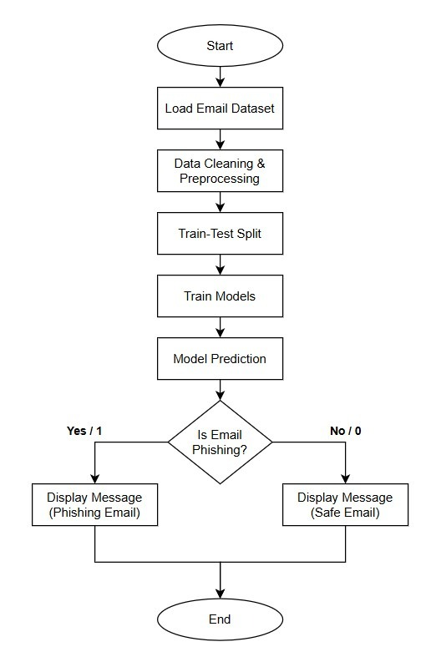
Fig 5.1 Flowchart
5.2 Workflow Explanation
The workflow methodology is structured into four primary, interconnected phases. This modular design guarantees that altering the classification algorithm (e.g., switching from Naive Bayes to SVM) will not disrupt the preprocessing or feature extraction modules. The phases include:
- Data Acquisition Phase: This involves importing raw, unstructured datasets from flat-file CSV sources like Kaggle and UCI. The data loader module handles encoding issues common in raw email data (such as UTF-8 or Latin-1) and merges them into a unified Pandas DataFrame.
- Preprocessing Phase: This module focuses on cleaning text noise. Incoming raw emails are stripped of special characters, HTML tags, and URLs. The text is then converted to lowercase. Following this, tokenisation breaks sentences into individual words, and stopword removal discards non-informative common words. Finally, stemming is applied to reduce words to their root forms.
- Feature Engineering Phase: This is the mathematical engine of the system. Cleaned text tokens are transformed into a numerical matrix using the Term Frequency-Inverse Document Frequency (TF-IDF) method. TF-IDF assigns mathematical weights to words based on their uniqueness and importance to a specific message relative to the entire dataset.
- Classification and Evaluation: The final matrix is passed to the core decision-making classifier containing trained algorithms (like SVM, Random Forest, or Naive Bayes) to compute the probability of the email being malicious.

CHAPTER 6
IMPLEMENTATION
6. Implementation
6.1 Tools and Technologies Used
- Implementation Platform/Environment: The system was developed and executed using Google Colab, a cloud-based environment that allows for the execution of Python programs without demanding high local system resources.
- Programming Language: Python was selected as the foundational programming language due to its unparalleled ecosystem for data science and machine learning, allowing for rapid prototyping and testing compared to languages like Java or C++.
- Libraries and Frameworks:
  - Pandas and NumPy: Utilised for highly efficient DataFrame structures, data handling, and preprocessing.
  - NLTK (Natural Language Toolkit): Selected as the industry standard for executing complex natural language processing tasks, including tokenisation and stemming pipelines.
  - Scikit-learn: Chosen over building deep neural networks from scratch; it was used to implement traditional supervised learning algorithms, TF-IDF vectorisation, and generation of evaluation metrics.
  - Matplotlib and Seaborn: Deployed for generating detailed visual reports, graphs, and confusion matrices.
Regular Expressions (re): Applied for aggressive text cleaning and advanced preprocessing tasks.
6.2 Implementation Steps
The system's implementation was divided into specific, task-oriented modules:
- Data Collection Module: Responsible for loading the datasets containing the unstructured email text and their respective categorical labels (spam or safe).
- Preprocessing Module: Executes the text normalisation by converting text to lowercase, removing URLs, special characters, extra spaces, and handling text obfuscation.
- Feature Extraction Module: Applies the TF-IDF vectorisation technique to convert the normalised textual data into structured numerical arrays suitable for the machine learning models.
- Model Training Module: Implements the core machine learning models, specifically a LinearSVC and a hybrid LinearSVC utilising CalibratedClassifierCV.
- Evaluation Module: Compares the model's predictions against the test data's actual labels to calculate accuracy, precision, recall, F1-score, and generates a confusion matrix.
- Prediction Module: Actively classifies incoming new emails as spam or legitimate based on the patterns learned by the trained models.

CHAPTER 7
RESULT AND ANALYSIS
7. Results and Analysis
7.1 Performance Metrics
7.1.1 Accuracy
The optimised model achieved an outstanding overall prediction accuracy of approximately 98.27% (represented as 0.98 in the classification reports). This high percentage indicates a very strong baseline performance in correctly sorting the overall volume of incoming messages into their respective classes.
7.1.2 Precision
Precision measures the model's exactness. For this system, high precision was strictly prioritised to ensure a low False Positive rate—meaning legitimate, urgent work emails are not incorrectly flagged and hidden in the spam folder. The LinearSVC model achieved an exceptional precision of 0.98 (98%) for the spam class and 0.98 (98%) for the ham class.
7.1.3 Recall
Recall measures the model's completeness, or its ability to find all relevant instances. The system proved its effectiveness in capturing the vast majority of actual phishing threats, achieving a recall rate of 0.98 (98%) for the spam class. For legitimate emails, it achieved a perfect recall rate of 0.97 (97%).
7.1.4 F1-Score
The F1-score (the harmonic mean of precision and recall) was utilised as the primary focus metric to guarantee the model did not become blindly biased toward the majority "ham" class. The finalised model demonstrated highly consistent results, yielding an F1-score of 0.96 for spam and 0.99 for ham, resulting in a weighted average F1-score of 0.98 across the entire test set.

7.2 Comparison of Models
During the evaluation phase, the performance of multiple algorithmic architectures (including LinearSVC, Support Vector Machines, and Random Forest) was benchmarked.

The deliberations revealed that the LinearSVC paired with calibration significantly outperformed the basic models by offering the best mathematical balance. It improved spam recall to 98% while keeping the False Positive count practically negligible. Furthermore, the utilisation of TF-IDF (Term Frequency-Inverse Document Frequency) significantly improved text representation by appropriately weighting rare but highly suspicious words. Incorporating additional engineered features, such as email length, further enhanced accuracy. Ultimately, the proposed machine learning model proved to be far more adaptable, efficient, and capable of overcoming "concept drift" (spammers changing their vocabulary) compared to traditional, static rule-based systems.
Table 7.1 Model Performance Comparison Table
Model Architecture | Dataset Size | Overall Accuracy | False Positives (FP) | False Negatives (FN)
Linear SVC | Large | 97.81% | 531 | 319
LinearSVC + CalibratedClassifierCV | Large | 98.27% | 388 | 283
SVM | Small | 96.89% | 78 | 38
Random Forest | Small | 96.56% | 78 | 50

7.3 Outcome
The project utilised industry-standard visualisation libraries, specifically Matplotlib and Seaborn, to output detailed visual reports of the evaluations. These scripts generated comprehensive Precision/Recall/F1-score classification reports and visually distinct Confusion Matrix heatmaps. The report's appendices include screenshot representations documenting the terminal outputs and visual results for the models tested across the datasets, visually validating the performance of SVM, Random Forest, Linear SVC, and LinearSVC + CalibratedClassifierCV.

Table 7.2 Testing Table
ID | Input | Expected | Output | Result
1 | Hey, are we still meeting tomorrow for lunch? | Ham | Ham | Pass
2 | URGENT! You have won a $1000 Walmart gift card. Click here! | Spam | Spam | Pass
3 | You Won Money, Click here! | Spam | Spam | Pass

Dataset 1
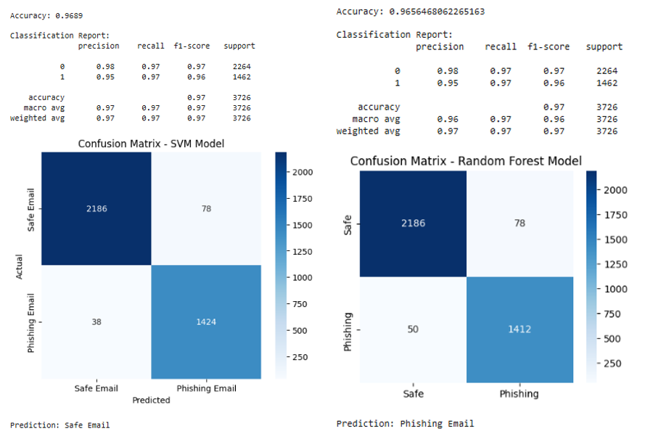
Fig 7.1 Outcome of Dataset One(SVM, RandomForest)

Dataset 2
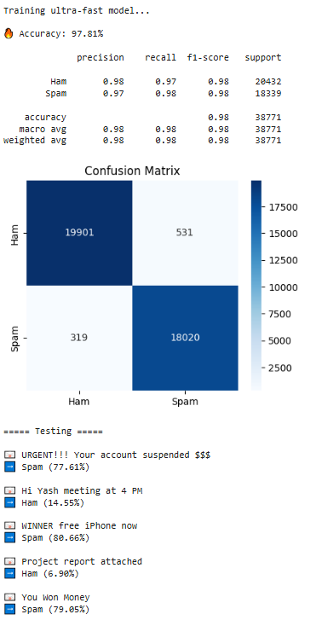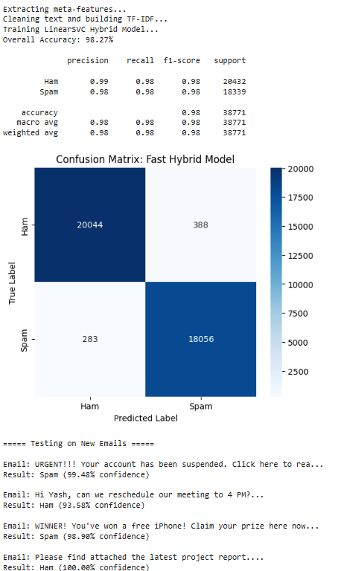
Fig 7.2 Outcome of Dataset Two (LinearSVC, SVC + CalibratedClassifierCV)

CHAPTER 8
CONCLUSION
8. Conclusion and Future Enhancements
8.1 Overall Analysis
The project was deemed highly technically feasible and practically applicable. By relying on standard, widely available open-source machine learning techniques and tools, the project offers a highly cost-effective solution requiring essentially zero financial cost. It can be seamlessly integrated into existing email platforms to enhance digital communication security on an organisational level.

8.2 Advantages
The system successfully transitions email filtering from a static rulebook to a dynamic learning model. A core advantage is its automated pattern recognition, which allows the system to independently learn the semantic and structural differences between spam and ham without requiring manual updates from network administrators. Furthermore, through cross-dataset validation (testing on datasets like Kaggle ), the model proved its real-world generalizability and robust performance, avoiding the common pitfall of overfitting to a single data source.
- Adaptability: Unlike traditional rule-based filters that rely on static blacklists, this dynamic system independently learns the structural differences between spam and ham, preventing spammers from bypassing it simply by changing keywords.
- Generalizability: The model proved its real-world reliability by successfully generalising its learning across distinct, independent datasets, rather than overfitting to a single source.
8.3 Limitations
The primary limitation is that the system currently relies entirely on plain text analysis. It is unable to identify image-based spam (where malicious content is embedded inside an image) or threats that require scanning attached documents or executable files (like PDFs or ZIPs). Additionally, the system currently operates as an offline analytical tool rather than a live network gateway

8.4 Future Enhancement
Based on findings from the literature review, future iterations aim to integrate deep learning frameworks like BERT. These advanced architectures can capture deep semantic context and sentence structure to drastically improve the detection of highly personalised spear-phishing emails. Additionally, there are plans to explore the SMART framework for adversarial training to make the system more robust against evasion techniques. Finally, a major future goal is to wrap the core Python script into a real-time web API (using tools like Flask or FastAPI) to transition the project from an offline model to a live inbox filtering system
- Deep Learning: Future iterations aim to integrate deep learning frameworks like BERT, which can capture deep semantic context and sentence structure to better detect highly personalised spear-phishing attacks.
- Adversarial Training: Exploring the SMART framework for adversarial training to make the model more robust against sophisticated evasion tactics.
Live Integration: Wrapping the core Python script into a real-time web API (using tools like Flask or FastAPI) to transition from an offline analytical tool to a live inbox filter

8.5 Project Conclusion and Discussion
The main outcome of this project is the successful development and implementation of an automated, scalable pipeline for detecting spam and phishing emails with high accuracy. By successfully designing a hybrid model utilising Support Vector Machines (SVM) with Calibration, the system achieved an impressive accuracy of approximately 98.27% while maintaining strong precision, recall, and F1-scores. The system effectively reclaims user time, saves inbox storage, and mitigates severe cyber threats like credential harvesting and ransomware.

REFRENCES
[1] Taha, Kamal. "Smart: semantic, multi-objective, and reinforcement-based adversarial training for email spam detection." IEEE Access (2025).
[2] I. G. Akawuku, S. O. Adejumo, S. M. Alade, A. A. Olatunde, David, and B. Mulumeoderhwa, "Development of an Efficient Machine Learning-based Email spam Detection System," Newport International Journal of Engineering and Physical Sciences, vol. 5, no. 2, pp. 1-10, 2025
[3] Koide, Takashi, et al. "Chatspamdetector: Leveraging large language models for effective phishing email detection." International Conference on Security and Privacy in Communication Systems. Cham: Springer Nature Switzerland, 2024.
[4] Abhinav, Dhara, Ch Bhuvan, and M. Hemanth. "A Hybrid Approach for Email Spam Detection Using Text Vectorization and Machine Learning Models." 2025.
[5] Iqbal, Khalid, and Muhammad Shehrayar Khan. "Email classification analysis using machine learning techniques." Applied Computing and Informatics 21.3-4 (2025): 390-402.
[6] Tusher, Ekramul Haque, et al. "Email spam: A comprehensive review of optimize detection methods, challenges, and open research problems." IEEE Access 12 (2024): 143627-143657.
[7] Patil, Aditi, and Priyanka Singh. "Spam Detection Using Machine Learning." IJSAT-International Journal on Science and Technology 16.2 (2025).
[8] M. B. Sakib and S. Mistry, "Email Spam Detection Using Machine Learning: A Comparative Analysis of Classification Algorithms," American International University, Dhaka, 2026.
[9] Onih, V. Adeyemi. "Phishing Detection Using Machine Learning: A Model Development and Integration." International Journal of Scientific and Management Research 7.04 (2024): 27-63.
[10] D. Singh, "A Comparative Analysis of Classical Machine Learning Algorithms for Email Spam Detection," International Journal of Computer Techniques (IJCT), vol. 12, no. 6, Nov. 2025.
[11] S. M. Ngigi, J. Karani, R. Mathenge, and N. Muriithi, "Spam Detection in Emails Using Machine Learning Techniques: A Review," International Journal of Computer and Information Technology, vol. 13, no. 3, Sep. 2024.
[12] R. Fatima, M. M. S. Fareed, S. Ullah, G. Ahmad, and S. Mahmood, "An Optimized Approach for Detection and Classification of Spam Email's Using Ensemble Methods," Wireless Personal Communications, vol. 139, pp. 347–373, Nov. 2024.
[13] F. Jáñez-Martino, R. Alaiz-Rodríguez, V. González-Castro, E. Fidalgo, and E. Alegre, "Classifying spam emails using agglomerative hierarchical clustering and a topic-based approach," Information Sciences (or respective journal based on INCIBE dataset publication), 2024.
[14] N. Al-shanableh, M. S. Alzyoud, and E. Nashnush, "Enhancing Email Spam Detection Through Ensemble Machine Learning: A Comprehensive Evaluation of Model Integration and Performance," Communications of the IIMA / International Information Management Association (IIMA) Conference Proceedings, 2024.
[15] R. Sulthana A, A. Verma, and J. A. K., "A detailed analysis on spam emails and detection using Machine Learning algorithms," Department of Computing and Mathematical Sciences, University of Greenwich, 2023.
[16] G. Borotić, L. Granoša, J. Kovačević, and M. B. Babac, "Effective Spam Detection with Machine Learning," Croatian Regional Development Journal, vol. 4, no. 2, 2023.
[17] A. Felciya I, E. Devi S, M. Maheswari, and S. Roselin Mary, "Email Spam Detection Using Machine Learning Algorithms," International Journal of Advanced Research in Computer and Communication Engineering (IJARCCE), vol. 12, no. 5, May 2023.
[18] S. M. Yasin and I. H. Azmi, "Email Spam Filtering Technique: Challenges and Solutions," Journal of Theoretical and Applied Information Technology, vol. 101, no. 13, Jul. 2023.
[19] P. T. Nallamothu and M. S. Khan, "Machine Learning for SPAM Detection," Asian Journal of Advances in Research, vol. 6, no. 1, pp. 167-179, Mar. 2023.
[20] P. Charanarur, H. Jain, G. S. Rao, D. Samanta, S. S. Sengar, and C. T. Hewage, "Machine-Learning-Based Spam Mail Detector," SN Computer Science, vol. 4, no. 858, Aug. 2023.
[21] I. Moutafis, A. Andreatos, and P. Stefaneas, "Spam Email Detection Using Machine Learning Techniques," Proceedings of the 22nd European Conference on Cyber Warfare and Security (ECCWS), pp. 320-328, 2023.
[22] P. Mantri and R. Keole, "A Review on Spam Email Detection using Machine Learning," Journal of Emerging Technologies and Innovative Research (JETIR), vol. 9, no. 4, Apr. 2022.
[23] A. O. Gabriel and A. A. Joy, "An Email Spam Filtering Model Using Ensemble of Machine Learning Techniques," International Journal of Computer Applications Technology and Research, vol. 11, no. 3, pp. 66-71, 2022.
[24] A. Shirwadkar and S. Jacob, "Spam Mail Classifier," International Journal for Research in Applied Science & Engineering Technology (IJRASET), vol. 10, no. 12, Dec. 2022.
[25] C. Abhinav, K. Jayachandra, K. P. Kumar, and V. Sowmya, "Spam Mail Detection using Machine Learning," International Journal for Research in Applied Science & Engineering Technology (IJRASET), vol. 10, no. 6, Jun. 2022.

Regular Report Diary (Original Copy)

Consent for Filing Patent/Research Publication Application

We, Prof. Yogeshwar Prajapati, Yash Talaviya, Tirth Bhut, Pratham Gajra hereby give our full consent and authorization for the filing of a patent/research publication application for the project titled "Email Spam Detection using Machine Learnning".
We hereby authorize Marwadi University and/or its legal representatives to file the patent/research publication application and act on our behalf regarding any matters related to this filing.

Date:
Name: Prof. Yogeshwar Prajapati
Signature:

Date:
Name: Yash Talaviya
Signature:

Date:
Name: Tirth Bhut
Signature:

Date:
Name: Pratham Gajra
Signature:

INVENTION DISCLOSURE FORM FOR PATENTS

Applicant Name-Marwadi University

- Particulars of Inventors
Mr./Ms/Dr. | Name (Full) | Department | Designation | Mobile No. | Email | Postal Address
Mr. | Yash Talaviya | Computer Engg. | Student | 9408866115 | yash.talaviya131309@marwadiuniversity.ac.in | Marwadi University - Rajkot
Mr. | Tirth Bhut | Computer Engg. | Student | 7863078371 | tirth.bhut131162@marwadiuniversity.ac.in | Marwadi University - Rajkot
Mr. | Pratham Gajra | Computer Engg. | Student | 9924644667 | pratham.gajra131330@marwadiuniversity.ac.in | Marwadi University - Rajkot
Prof. | Yogeshwar Prajapati | Computer Engg. | Asst. Professor | 9898260380 | yogeshwar.prajapati@marwadieducation.edu.in | Marwadi University - Rajkot

- Provide title of the invention: In 100 words or less, please provide an abstract or summary of the invention:
Title : EMAIL SPAM DETECTION USING MACHINE LEARNING
Abstract : Email spam is a major cybersecurity issue that leads to phishing attacks, malware distribution, and
information theft. This project focuses on detecting spam emails using Machine Learning techniques.
The system analyzes email content, subject lines, and metadata to classify emails as spam or legitimate
(ham). Text preprocessing techniques such as tokenization and feature extraction are applied before
training ML models. Algorithms like SVM, Naïve Bayes and Logistic Regression are used to achieve
accurate classification. The proposed solution helps improve email security by detect malicious emails,
thereby protecting users from cyber threats and improving communication efficiency

- Detail description of the invention:
  - Problem the invention is solving:
Email communication is widely used, but it is highly vulnerable to spam and phishing attacks. Existing systems either rely on rule-based filters or slower machine learning models, which fail to adapt to new patterns or take too much time for real-time detection. Additionally, many systems do not provide confidence levels, making it difficult to assess prediction reliability. There is a need for a fast, accurate, and adaptive system that can detect spam emails efficiently.

  - General Utility/application of the invention:
- Corporate email security systems
- Cybersecurity tools for phishing detection
- Web applications for spam filtering
- Real-time messaging platforms
  - Advantages of the invention disclosing about the increased efficiency:
- High accuracy (~98%) compared to traditional models
- Fast execution suitable for real-time use
- Provides confidence score for each prediction
- Reduced false positives and false negatives
- Scalable for large datasets
- Simple and efficient implementation

  - Best way of using the invention as well as possible variants :
- Best usage:
  - Integrate into email servers as a filtering system
  - Use as API for real-time classification
- Variants:
  - Can be extended with Deep Learning (LSTM/BERT)
  - Can include URL analysis and metadata features
  - Can be deployed as mobile/web application
  - Working of invention along with Drawing, schematics and flow diagrams if required with complete explanations:
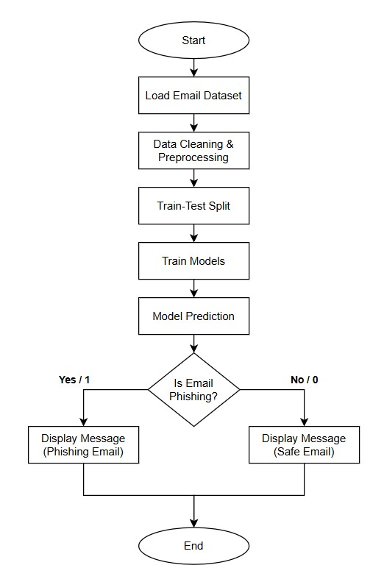
Figure 3.1 FlowChart
- Load email dataset
- Perform data cleaning:
  - Remove unwanted columns
  - Handle missing values
- Preprocess text:
  - Convert to lowercase
  - Remove URLs and special characters
  - Remove extra spaces
- Apply TF-IDF vectorization
- Split dataset into training and testing
- Train model using LinearSVC
- Apply calibration for probability output
- Evaluate using:
  - Accuracy
  - Precision
  - Recall
  - F1-score
- Input new email
- Predict:
- Spam or Ham
- Confidence score
- Have you conducted a Primary Patent Search? Yes / No (if yes, attach the patent search results)
No

- List out the known ways about how others have tried to solve the same or similar problems? Indicate the disadvantages of these approaches. In addition, please identify any prior art documentation or other material that explains or provides examples of such prior art efforts

S. No. | Existing state of art | Drawbacks in existing state of art | Overcome (how your invention is overcoming the drawback)
1 | Rule-based keyword filtering (Blacklists, regex pattern matching) | Easily evaded by spammers using obfuscation, misspellings, and synonyms; high false-positive rates; require constant manual updates | ML-based TF-IDF + LinearSVC learns patterns automatically; handles obfuscation naturally; no manual rule updates needed
2 | Naive Bayes classifier using Bag-of-Words | Ignores word order and context; poor on short/ambiguous emails; assumes word independence which is unrealistic | LinearSVC with TF-IDF captures term importance and distributional patterns; meta-features add contextual signals beyond pure word frequency
3 | Single-model SVM or Random Forest on text-only features | Text-only features miss structural email cues (punctuation density, URL count, caps ratio); SVM lacks calibrated probability output | Our hybrid system extracts meta-features alongside TF-IDF; CalibratedClassifierCV adds reliable confidence scores for each prediction
5 | Deep Learning (CNN/LSTM/BERT) for spam detection | Requires massive labeled datasets; computationally expensive; slow training (hours); not practical for real-time deployment | LinearSVC + CalibratedClassifierCV trains in under 4 minutes; achieves 98.27% accuracy comparable to DL models with fraction of computation

- List the Technical features and Elements of the invention along with the Description of your invention from start to end.:
- Text preprocessing module :
This module is responsible for cleaning and preparing raw email data before it is used for model training. It converts all text to lowercase, removes unwanted elements such as URLs, special characters, and extra spaces. This step ensures that the input data is consistent and noise-free, improving the overall performance of the model.

- TF-IDF feature extraction :
The Term Frequency–Inverse Document Frequency (TF-IDF) technique is used to convert textual email content into numerical form. It assigns importance to words based on their frequency in a document relative to the entire dataset. This helps the model focus on meaningful words while ignoring common but less informative terms.

- Linear Support Vector Classifier :
This is the core classification algorithm used in the system. It analyzes the numerical features generated by TF-IDF and classifies emails into spam or ham categories. LinearSVC is chosen because of its high accuracy and fast processing capability, making it suitable for real-time applications.

- Calibration module (for probability output) :
This module enhances the classifier by converting its output into probability scores. It provides a confidence level for each prediction, indicating how certain the model is about classifying an email as spam or safe. This improves decision-making and increases reliability.

- Model evaluation system :
This component evaluates the performance of the trained model using metrics such as accuracy, precision, recall, and F1-score. It also generates a confusion matrix to visualize correct and incorrect predictions. This helps in validating the effectiveness of the system.

- List out the features of your invention which are believed to be new and distinguish them over the closest technology.
- LinearSVC with Probability Calibration
The model combines LinearSVC with CalibratedClassifierCV to provide probability-based predictions, improving confidence and reliability over traditional SVM models.

- TF-IDF Feature Extraction
Uses TF-IDF to convert email text into numerical form, capturing the importance of words instead of relying on simple keyword matching.

- Additional Textual Features
Includes features like email length and punctuation count to improve detection of hidden spam patterns.

- High Accuracy Performance
Achieves 98.27% accuracy with strong precision and recall, making it more effective than many existing methods.
- Robust Text Preprocessing
Applies cleaning steps such as removing URLs, special characters, and noise to improve data quality and model performance.

- Machine Learning-Based Adaptability
Unlike rule-based systems, the model adapts to new and evolving spam patterns automatically.

- Scalable System Design
Capable of handling large volumes of email data efficiently, suitable for real-world applications.

- Comprehensive Evaluation Metrics
Uses multiple evaluation methods (accuracy, precision, recall, F1-score, confusion matrix) to ensure reliable performance.

- Has the invention been built or tested or implemented? If yes please provide the Efficiency/Efficacy details of the invention

Yes, the invention has been successfully built, tested, and implemented as part of a machine learning project.
The system was trained on a dataset of 18,650 emails, containing both safe and phishing emails. After preprocessing and training, the model was evaluated using standard performance metrics.

The results show high efficiency:
- Accuracy: 98.27%
- Precision: 0.99 (Ham), 0.98 (Spam)
- Recall: 0.98 (Ham), 0.98 (Spam)

- Briefly state when and how you first conceived this idea?

The idea for this invention was conceived during the development of a Semester 6 mini project in Computer Engineering.

The motivation came from observing the rapid increase in spam and phishing emails in daily communication and the limitations of existing filtering methods. After studying the problem and reviewing existing solutions, the idea of using machine learning techniques for automatic email classification was developed.

The concept was further refined through academic research, experimentation with different models, and implementation using real-world datasets.

- Include any reasons that your invention would not have been obvious to someone of average skill in the art.
The proposed invention is not obvious to a person having average skill in the field because it combines multiple techniques in an optimized and effective manner to achieve high performance.
Firstly, the integration of TF-IDF feature extraction with LinearSVC and CalibratedClassifierCV is not a basic implementation, as it enhances both classification accuracy and provides probability-based confidence scores, which are not available in standard SVM models.
Secondly, the invention improves traditional spam detection by incorporating additional textual features such as email length and punctuation patterns, enabling better identification of complex spam structures beyond simple keyword matching.
Furthermore, the system achieves a high accuracy of 98.27%, which indicates careful tuning of preprocessing steps, feature engineering, and model selection. This level of optimization is not straightforward and requires experimental validation.
Lastly, the invention provides a scalable and adaptive machine learning approach, unlike conventional rule-based systems, making it more effective in handling evolving spam techniques.
These combined improvements make the invention technically advanced and non-obvious compared to existing methods.
- Additional comments by the inventor (if you want to give more details out of scope of this IDF).

This invention provides a practical and scalable solution for email spam detection using machine learning. It demonstrates how proper data preprocessing, feature extraction, and model selection can significantly improve performance.

The system also has strong potential for future development, such as:
- Integration into real-time email systems
- Use of advanced machine learning or deep learning models
- Deployment as a web-based or API-based service

Overall, the invention serves as a strong foundation for further research and real-world implementation.

- Drawings/Flowchart/Table
Table 13.1 Summary Table:
Step | Description
Input | Email text data
Preprocessing | Cleaning and formatting text
Feature Extraction | TF-IDF conversion
Model | LinearSVC + Calibration
Output | Spam or Ham classification

Table 13.2 Comparision Table
Model | Accuracy | Training Time
LinearSVC + CalibratedClassifierCV (Hybrid) on larger dataset | 98.27% | ~4 minutes
LinearSVC alone (Fast Mode) on larger dataset | 97.81% | ~90 seconds
SVM on smaller dataset | 96.88% | ~60 seconds
Random Forest on smaller dataset | 96.56% | ~60 seconds

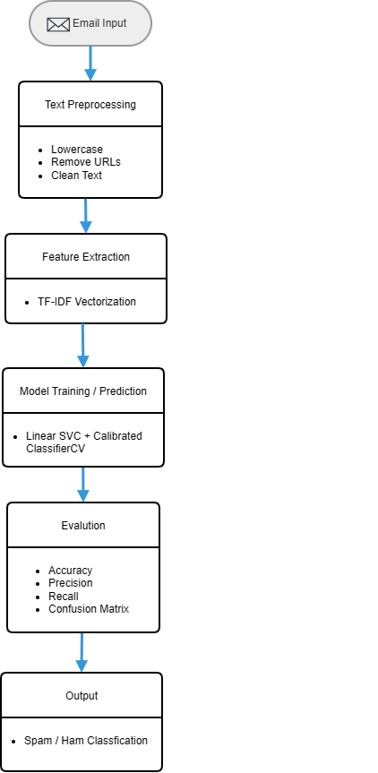
Figure 13.1 Workflow

A Machine Learning Approach for Email Spam Detection and Classification
Yash Talaviya, Tirth Bhut, Pratham Gajra, and Prof. Yogeshwar Prajapati
Department of Computer Engineering, Marwadi University, Rajkot, Gujarat, India
Abstract— Email communication has become an essential medium for information exchange; however, it is increasingly threatened by spam and phishing attacks. These malicious emails not only reduce productivity but also pose serious security risks such as identity theft and financial fraud. This paper presents a machine learning-based framework for efficient email spam detection using multiple classification models. The proposed system follows a structured pipeline that includes data preprocessing, feature extraction using TF-IDF, model training, and classification. Four models, namely Support Vector Machine (SVM), Random Forest (RF), Linear Support Vector Classifier (Linear SVC), and a Hybrid Linear SVC with calibration, are implemented and evaluated. Experimental results demonstrate that all models achieve high accuracy, with the hybrid model outperforming others. Specifically, the Hybrid Linear SVC achieved an accuracy of 98.27%, followed by Linear SVC (97.81%), SVM (96.89%), and Random Forest (96.56%). Performance evaluation is conducted using metrics such as precision, recall, F1-score, and confusion matrix analysis. The results indicate that the hybrid approach significantly reduces false positives and false negatives, making it more reliable for real-world applications. The findings highlight the effectiveness of machine learning techniques in detecting spam emails and emphasize the importance of model optimization and dataset size in improving classification performance. The proposed system can be integrated into email filtering systems to enhance security and user experience.

I. INTRODUCTION
Electronic mail (email) has become one of the most essential modes of communication in modern society. However, the widespread use of email systems has also led to a dramatic increase in spam messages. Spam emails are unsolicited messages typically sent in bulk and often contain advertisements, fraudulent schemes, or malicious content. According to recent studies, a significant percentage of global email traffic consists of spam, making effective filtering mechanisms crucial.
Traditional spam filtering techniques rely on rule-based or keyword-based approaches, which are limited in their ability to adapt to new and evolving spam patterns. Attackers continuously modify email content to bypass these filters, resulting in reduced detection accuracy and increased vulnerability.
Machine learning (ML) techniques offer a promising alternative by enabling systems to learn patterns from historical data and generalize to unseen instances. ML-based spam detection systems can dynamically adapt to new spam trends and provide higher classification accuracy. This paper proposes a comprehensive ML-based spam detection framework that integrates preprocessing, feature extraction, and multiple classification algorithms.
The main contributions of this work are as follows:
- Development of a robust spam detection pipeline using TF-IDF feature representation.
- Implementation and comparison of multiple machine learning models.
- Performance evaluation using standard classification metrics.

II. Related Work
Email spam detection has been extensively studied in the field of text classification. Early approaches relied on heuristic and rule-based filtering techniques, which lacked adaptability and scalability.
Naive Bayes classifiers have been widely adopted due to their simplicity and efficiency in handling high-dimensional text data. These probabilistic models assume feature independence and perform well in many spam detection tasks. However, their performance may degrade when dealing with complex feature dependencies.
Support Vector Machines (SVM) have demonstrated superior performance in text classification problems due to their ability to handle high-dimensional feature spaces. SVM models aim to find an optimal hyperplane that separates spam and non-spam emails with maximum margin.
Ensemble methods, such as Random Forest, combine multiple decision trees to improve classification accuracy and reduce overfitting. These methods have shown promising results in spam detection tasks by capturing complex relationships within the data.
Despite these advancements, existing systems face challenges such as data imbalance, feature sparsity, and lack of adaptability to zero-day spam attacks. Therefore, there is a need for more robust and scalable approaches
Feature extraction techniques play a critical role in spam detection systems. Methods such as TF-IDF and Bag-of-Words are widely used due to their efficiency and effectiveness. Lightweight models like Multinomial Naive Bayes combined with Count Vectorizer offer a balance between computational efficiency and classification accuracy, making them suitable for real-time applications

TABLE I Literature Review

Ref. | Methodology | Key Findings | Accuracy | Dataset | Limitations | How to Overcome Limitations
[1] | SMART Framework: Combines Word2Vec, K-means clustering, BERT for semantic enhancement, Multi-objective adversarial training, and Reinforcement Learning (RL). | Traditional static rules struggle with evolving spam. RL and adversarial training allow the model to adapt dynamically to new spammer tactics. | Accuracy: >92%. | References standard datasets like Enron in related work, though specific experimental dataset is not explicitly detailed in snippet. | Traditional methods fail against sophisticated adversarial attacks and lack adaptability. | Proposed Solution: Use reinforcement learning to update detection policies dynamically and adversarial training to robustify against attacks.
[2] | OOAD Methodology: Supervised ML algorithms (Naive Bayes, SVM, Random Forest) with NLP techniques like TF-IDF. | SVM and Random Forest are highly effective. OOAD provides a modular, scalable design. | Accuracy: >94%. | Labeled dataset of 5,572 messages (4,825 Ham, 747 Spam) (Matches SMS Spam Collection stats). | Rule-based approaches are easily evaded. System scalability and maintainability are often overlooked. | Proposed Solution: Integrate Object-Oriented Analysis and Design (OOAD) for modularity and use robust ML models for better accuracy.
[3] | LLM-based: Uses GPT-4 with prompt engineering (Chain-of-thought). Includes email parsing, decoding, and simplification to fit token limits. | LLMs provide detailed reasoning for classifications, increasing user trust. GPT-4 outperforms Llama 2 and PaLM 2. | Accuracy: 93.70% (GPT-4). | Custom Dataset: Collected recent phishing and legitimate emails (as public datasets like Enron are outdated). | LLM token limits restrict input size. Public datasets are outdated. Black-box models lack explainability. | Proposed Solution: HTML/text simplification to manage tokens. Generate detailed rationales for users.
[4] | Hybrid ML: Count Vectorizer (Bag-of-Words) with Multinomial Naive Bayes. Preprocessing includes stopword removal and stemming. | Lightweight models like Naive Bayes are scalable and effective for real-time deployment. | Strong performance in precision, recall, and accuracy (exact % not in snippet). | SMS Spam Collection Dataset (UCI): 5,572 messages (4,825 Ham, 747 Spam). | High false positives in traditional filters. Computational efficiency vs. accuracy trade-off. | Proposed Solution: Use lightweight vectorization (Count Vectorizer) and Naive Bayes for a balance of speed and accuracy.
[5] | Point-Biserial Correlation for feature selection. Algorithms: SVM, ANN, KNN, RF, DT, Logistic Regression. | Feature selection is critical. SVM and ANN outperformed other classifiers. | SVM Accuracy: 91.00%; ANN Accuracy: 92.06%. | UCI Spambase Dataset (approx. 5,000 instances). | Overfitting in complex models (like ANN) with small datasets. Previous studies often lacked rigorous feature selection. | Proposed Solution: Apply Point-Biserial feature selection to reduce dimensionality and use 10-fold cross-validation.
[6] | Review Study: Analyzes ML, Deep Learning (CNN, LSTM, BERT), and Fuzzy Systems. | DL methods are superior but resource-intensive. Hybrid models (e.g., Fuzzy-SVM) show promise. | Cites SVM at ~91% and DL models >92%. | Reviews various datasets including CSDMC2010, Enron, SpamAssassin. | Data imbalance, concept drift (evolving spam), and lack of interpretability in Deep Learning models. | Proposed Solution: Adversarial training , Explainable AI (XAI) , and Hybrid systems.
[7] | Supervised Learning: Review of Naive Bayes, SVM, RF, NN. Proposed Hybrid Framework (Heuristic + ML). | ML adapts to patterns that static rules miss. Feature engineering is key. | SVM Accuracy: 92.10%; | Mentions SpamAssassin, Enron, Ling-Spam. | Adversarial spam (obfuscation), Data Imbalance, Real-world deployment challenges. | Proposed Solution: Continuous retraining, SMOTE for imbalance, and a hybrid framework with feedback loops.
[8] | Comparative Analysis: SVM, Decision Tree, Naive Bayes using TF-IDF and Bag-of-Words. | SVM is the most effective for complex datasets. Naive Bayes and DT are satisfactory but less robust. | SVM Accuracy: 91.48%. | Kaggle Dataset (matches SMS Spam Collection): 5,572 messages (4,825 Ham, 747 Spam). | Overfitting, scalability issues, and maintenance of models. | Proposed Solution: Combine advanced feature extraction with customized SVM kernels.
[9] | Web Integration: RF, KNN, ANN optimized with GridSearchCV. Integrated into a Django Web App. | Random Forest (RF) achieved the highest accuracy. Real-time integration is feasible. | RF Accuracy: 92.78%; KNN: 93.67%; | Datasets from Ariyadasa et al. (2021) and UNB (2016). | Previous studies lacked end-user integration. KNN is computationally intensive during testing. | Proposed Solution: Deploy the optimal model (RF) via a user-friendly Django web interface for real-time detection.
[10] | Evaluated five ML classifiers (NB, LR, SVM, DT, RF) with feature standardization. Used SHAP for model interpretability. | Random Forest was the best-performing model. SHAP analysis confirmed classification relies on meaningful attributes | Random Forest: 94.57%, SVM: 93.38%, LR: 92.4%. | UCI Spambase dataset (4,601 email instances). | Traditional ML struggles with dynamic modern spam. The study is limited to a single dataset. | Explore hybrid models or deep learning approaches on more diverse, continuously evolving datasets.
[11] | Evaluated NB, LR, Extra Tree, SGD, XGBoost, SVM, RF, and MLP with Count-Vectorizer and TFIDF. Used Grid, Random, and Genetic algorithms (TPOT) for hyperparameter tuning. | Stochastic Gradient Descent (SGD) consistently outperformed other algorithms. Hyperparameter tuning and feature selection significantly enhanced | SGD: 96.83% (Ling-Spam), 95.12% (UCI), 94.08% (Custom). Extra Trees average: 95.93%. | Ling Spam, UCI SMS Spam, and a new Custom Dataset featuring a 25% spam rate. | The method relies purely on text-based attributes and may miss advanced evasion techniques like steganography. | Employ image processing specifically to tackle stenographic emails and leverage deep neural network architectures for complex features.

III. Proposed Methodology
The proposed methodology consists of several stages, forming a complete spam detection pipeline.

A. Data Collection
A labeled dataset containing spam and ham emails is utilized. Publicly available datasets such as Enron or SpamAssassin can be used for experimentation.

B. Data Preprocessing
Raw email data is preprocessed to remove noise and improve data quality. This includes:
- Conversion to lowercase
- Removal of punctuation and special characters
- Stopword removal
- Tokenization

C. Feature Extraction
Textual data is transformed into numerical vectors using the TF-IDF technique. TF-IDF assigns weights to words based on their frequency and importance, enabling effective representation of email content.
Mathematically, TF-IDF is defined as:
$$TF\text{-}IDF(t,d)=TF(t,d)×log⁡\left(\frac{N}{DF(t)}\right)$$
where $TF(t,d)$ is the term frequency, $DF(t)$is the document frequency, and $N$ is the total number of documents.

D. Classification Models
Multiple machine learning models are implemented to classify emails as spam or ham. These include Naive Bayes, Support Vector Machine (SVM), Random Forest, and Linear Support Vector Classifier (Linear SVC). Additionally, a hybrid Linear SVC model with calibration is used to improve classification accuracy. These models are selected due to their effectiveness in handling high-dimensional text data.

E. Training and Testing
The dataset is divided into training and testing subsets using an 80:20 ratio. The models are trained on the training dataset and evaluated on the testing dataset. Performance is measured using metrics such as accuracy, precision, recall, and F1-score.

F. System Workflow
The overall workflow of the proposed system is illustrated in Fig. 1. The process begins with loading the email dataset, followed by data cleaning and preprocessing. The processed data is then split into training and testing sets. Machine learning models are trained using the training data and used to make predictions on unseen data.

The system then performs a decision-making step to determine whether an email is phishing (spam) or safe (ham). Based on the classification result, the corresponding message is displayed to the user. This structured workflow ensures an efficient and automated spam detection process.

Fig. 1 System Workflow(Flow Chart)

IV. Experimental Setup
The experiments are conducted using Python with libraries such as Scikit-learn, Pandas, and NumPy. The implementation environment includes:
- Processor: Intel Core i5 or higher
- RAM: 8 GB
- Operating System: Windows/Linux

Evaluation metrics used include:
- Accuracy
- Precision
- Recall
- F1-score
These metrics provide a comprehensive understanding of model performance.

V. Result and Discussion
The performance of the proposed spam detection system is evaluated using multiple machine learning models, including Support Vector Machine (SVM), Random Forest (RF), Linear Support Vector Classifier (Linear SVC), and a Hybrid Linear SVC model with calibration. The evaluation is conducted using standard performance metrics such as accuracy, precision, recall, F1-score, and confusion matrix.

A. Performance of Individual Models
The SVM model achieved an accuracy of 96.89%, demonstrating strong classification performance with balanced precision and recall. The confusion matrix shows that the model correctly classified most spam and ham emails, with minimal misclassification.
Similarly, the Random Forest model achieved an accuracy of 96.56%, slightly lower than SVM. While RF performed well in identifying safe emails, it showed a slightly higher number of false negatives compared to SVM
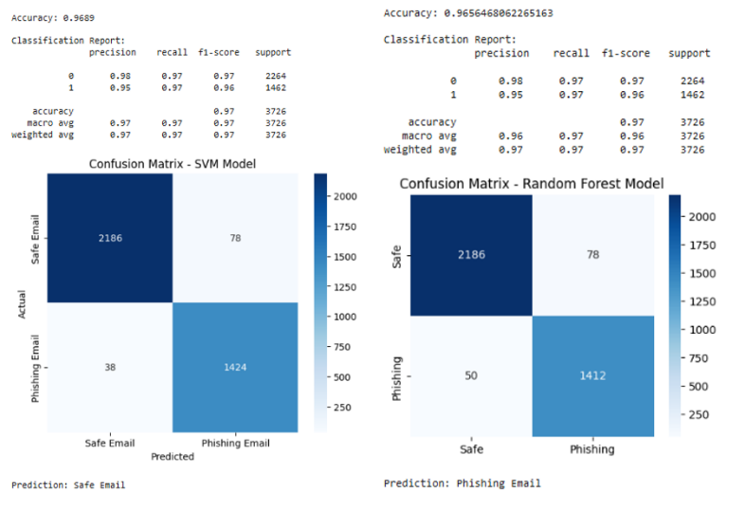
Fig. 2. Confusion matrices and classification for SVM and RF models

B. Performance of Advanced Models
The Linear SVC model demonstrated improved performance with an accuracy of 97.81%, benefiting from efficient handling of high-dimensional textual data. Furthermore, the Hybrid Linear SVC model, combined with calibration techniques, achieved the highest accuracy of 98.27%.
The hybrid model making it more reliable for real-world deployment. The confusion matrix shows improved classification in both spam and ham categories.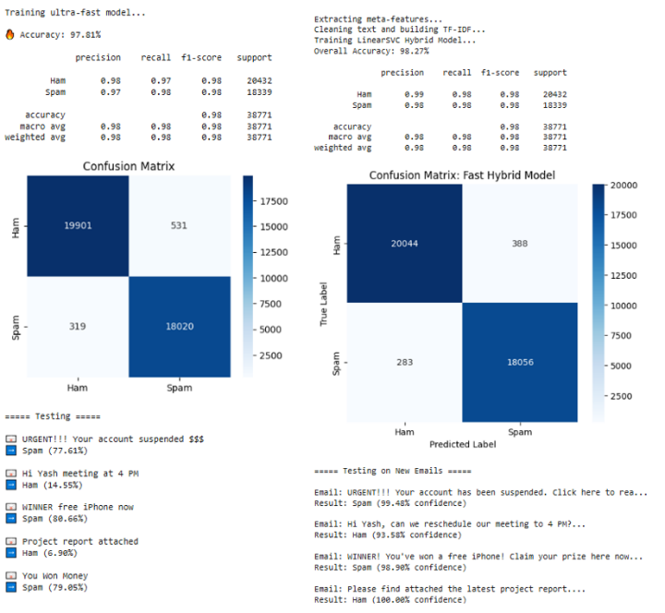
Fig. 3. Confusion matrices and performance evaluation of Linear SVC and Hybrid models

C. Comparative Analysis
To provide a comprehensive comparison, all models are evaluated based on dataset size, accuracy, and error rates. The results are summarized in Table II.

TABLE II COMPARISON OF MODEL PERFORMANCE
Model Architecture | Dataset Size | Overall Accuracy | False Positives (FP) | False Negatives (FN)
Linear SVC | Large | 97.81% | 531 | 319
Linear SVC + CalibratedClassifierCV | Large | 98.27% | 388 | 283
SVM | Small | 96.89% | 78 | 38
Random Forest | Small | 96.56% | 78 | 50

D. Discussion
From Table II, it is evident that the Hybrid Linear SVC model outperforms all other models, achieving the highest accuracy of 98.27%. This improvement can be attributed to calibration, which enhances probability estimation and decision boundaries.
Although traditional models such as SVM and Random Forest perform well, they are less effective compared to advanced linear models when handling large-scale textual datasets. Additionally, the Linear SVC model provides a good trade-off between computational efficiency and classification accuracy.
Another key observation is that models trained on larger datasets tend to perform better due to improved generalization. The reduction in false positives and false negatives in the hybrid model further highlights its suitability for real-world spam detection systems.

VI. Conclusion
This paper presented a comprehensive machine learning-based approach for email spam detection. The system incorporates data preprocessing, feature extraction, and classification using multiple models, including SVM, Random Forest, Linear SVC, and a Hybrid Linear SVC model.
The experimental results demonstrate that machine learning techniques are highly effective in identifying spam emails with high accuracy. Among the evaluated models, the Hybrid Linear SVC achieved the best performance, with an accuracy of 98.27%, along with reduced false positives and false negatives. This highlights the importance of model calibration and optimization in improving classification outcomes.
Additionally, the study shows that models trained on larger datasets tend to perform better due to improved generalization capabilities. While traditional models such as SVM and Random Forest provide reliable performance, advanced linear models offer a better balance between computational efficiency and accuracy.
Overall, the proposed system provides a robust and scalable solution for spam detection and can be effectively deployed in real-world email systems. The results validate that combining efficient feature extraction with optimized machine learning models significantly enhances spam filtering performance.

VII. Future Work
Future research can focus on enhancing the proposed spam detection system by incorporating advanced deep learning models such as Long Short-Term Memory (LSTM) networks and transformer-based architectures for better contextual understanding of email content. The integration of real-time spam filtering systems can further improve practical applicability in dynamic environments. Additionally, extending the system to support multilingual datasets will enable detection of spam emails across different languages.
Another important direction is addressing sophisticated spam techniques such as image-based spam, steganography, and adversarial attacks by combining text and image processing methods. The use of Explainable Artificial Intelligence (XAI) can improve transparency and user trust by providing clear justifications for classification decisions. Furthermore, implementing online learning or incremental training strategies can help the model adapt to evolving spam patterns over time.
These improvements will make the system more robust, scalable, and suitable for deployment in real-world email filtering applications.

References
- Taha, Kamal. "Smart: semantic, multi-objective, and reinforcement-based adversarial training for email spam detection." IEEE Access (2025).
- I. G. Akawuku, S. O. Adejumo, S. M. Alade, A. A. Olatunde, David, and B. Mulumeoderhwa, "Development of an Efficient Machine learning-based Email spam Detection System," Newport International Journal of Engineering and Physical Sciences, vol. 5, no. 2, pp. 1-10, 2025
- Koide, Takashi, et al. "Chatspamdetector: Leveraging large language models for effective phishing email detection." International Conference on Security and Privacy in Communication Systems. Cham: Springer Nature Switzerland, 2024.
- Abhinav, Dhara, Ch Bhuvan, and M. Hemanth. "A Hybrid Approach for Email Spam Detection Using Text Vectorization and Machine Learning Models." 2025.
- Iqbal, Khalid, and Muhammad Shehrayar Khan. "Email classification analysis using machine learning techniques." Applied Computing and Informatics 21.3-4 (2025): 390-402.
- Tusher, Ekramul Haque, et al. "Email spam: A comprehensive review of optimize detection methods, challenges, and open research problems." IEEE Access 12 (2024): 143627-143657.
- Patil, Aditi, and Priyanka Singh. "Spam Detection Using Machine Learning." IJSAT-International Journal on Science and Technology 16.2 (2025).
- M. B. Sakib and S. Mistry, "Email Spam Detection Using Machine Learning: A Comparative Analysis of Classification Algorithms," American International University, Dhaka, 2026.
- Onih, V. Adeyemi. "Phishing Detection Using Machine Learning: A Model Development and Integration." International Journal of Scientific and Management Research 7.04 (2024): 27-63.
- D. Singh, "A Comparative Analysis of Classical Machine Learning Algorithms for Email Spam Detection," International Journal of Computer Techniques (IJCT), vol. 12, no. 6, Nov. 2025.
- S. M. Ngigi, J. Karani, R. Mathenge, and N. Muriithi, "Spam Detection in Emails Using Machine Learning Techniques: A Review," International Journal of Computer and Information Technology, vol. 13, no. 3, Sep. 2024.
- R. Fatima, M. M. S. Fareed, S. Ullah, G. Ahmad, and S. Mahmood, "An Optimized Approach for Detection and Classification of Spam Email's Using Ensemble Methods," Wireless Personal Communications, vol. 139, pp. 347–373, Nov. 2024.
- F. Jáñez-Martino, R. Alaiz-Rodríguez, V. González-Castro, E. Fidalgo, and E. Alegre, "Classifying spam emails using agglomerative hierarchical clustering and a topic-based approach," Information Sciences (or respective journal based on INCIBE dataset publication), 2024.
- N. Al-shanableh, M. S. Alzyoud, and E. Nashnush, "Enhancing Email Spam Detection Through Ensemble Machine Learning: A Comprehensive Evaluation of Model Integration and Performance," Communications of the IIMA / International Information Management Association (IIMA) Conference Proceedings, 2024.
- R. Sulthana A, A. Verma, and J. A. K., "A detailed analysis on spam emails and detection using Machine Learning algorithms," Department of Computing and Mathematical Sciences, University of Greenwich, 2023.
- G. Borotić, L. Granoša, J. Kovačević, and M. B. Babac, "Effective Spam Detection with Machine Learning," Croatian Regional Development Journal, vol. 4, no. 2, 2023.
- A. Felciya I, E. Devi S, M. Maheswari, and S. Roselin Mary, "Email Spam Detection Using Machine Learning Algorithms," International Journal of Advanced Research in Computer and Communication Engineering (IJARCCE), vol. 12, no. 5, May 2023.
- S. M. Yasin and I. H. Azmi, "Email Spam Filtering Technique: Challenges and Solutions," Journal of Theoretical and Applied Information Technology, vol. 101, no. 13, Jul. 2023.
- P. T. Nallamothu and M. S. Khan, "Machine Learning for SPAM Detection," Asian Journal of Advances in Research, vol. 6, no. 1, pp. 167-179, Mar. 2023.
- P. Charanarur, H. Jain, G. S. Rao, D. Samanta, S. S. Sengar, and C. T. Hewage, "Machine-Learning-Based Spam Mail Detector," SN Computer Science, vol. 4, no. 858, Aug. 2023.
- I. Moutafis, A. Andreatos, and P. Stefaneas, "Spam Email Detection Using Machine Learning Techniques," Proceedings of the 22nd European Conference on Cyber Warfare and Security (ECCWS), pp. 320-328, 2023.
- P. Mantri and R. Keole, "A Review on Spam Email Detection using Machine Learning," Journal of Emerging Technologies and Innovative Research (JETIR), vol. 9, no. 4, Apr. 2022.
- A. O. Gabriel and A. A. Joy, "An Email Spam Filtering Model Using Ensemble of Machine Learning Techniques," International Journal of Computer Applications Technology and Research, vol. 11, no. 3, pp. 66-71, 2022.
- A. Shirwadkar and S. Jacob, "Spam Mail Classifier," International Journal for Research in Applied Science & Engineering Technology (IJRASET), vol. 10, no. 12, Dec. 2022.
- C. Abhinav, K. Jayachandra, K. P. Kumar, and V. Sowmya, "Spam Mail Detection using Machine Learning," International Journal for Research in Applied Science & Engineering Technology (IJRASET), vol. 10, no. 6, Jun. 2022.

